TRANSPORTATION CONTROL MEASURE

INFORMATION DOCUMENTS

Contract No. 68-D9-0073
Work Assignment No. II-8

Prepared for

U.S. Environmental Protection Agency
Office of Mobile Sources

by

Cambridge Systematics, Inc.
222 Third Street
Cambridge, Massachusetts 02142

With

Comsis Corp.
K.T. Analytics, Inc.
Deakin, Harvey, Skabardonis

March 1992

________________________________________________________________________

Preface

The Environmental Protection Agency is required under Section 108(f) of the Clean Air Act, as amended in 1990, to prepare information “regarding the formulation and emission reduction potential of transportation control measures related to criteria pollutants and their precursors.” These information documents have been developed “in consultation with the Secretary of Transportation, and after providing public notice and opportunity for comment.”

This report constitutes information documents for the following sixteen categories of transportation control measures:

- Trip Reduction Ordinances
- Employer-Based Transportation Management Programs
- Work Schedule Changes
- Area-wide Rideshare Incentives
- Improved Public Transit
- High Occupancy Vehicle Facilities
- Traffic Flow Improvements
- Parking Management
- Park-and-Ride/Fringe Parking
- Bicycle and Pedestrian Programs
- Special Events
- Vehicle Use Limitations/Restrictions
- Accelerated Retirement of Vehicles
- Activity Centers
- Extended Vehicle Idling
- Extreme Low-Temperature Cold Starts

This Preface is immediately followed by a table identifying examples of the kinds of transportation control measures that can be included in each of the sixteen categories. The report then follows with a Summary section that includes a discussion of implementation experience with transportation control measures, along with summaries of each of the individual TCMs. A transportation/Air Quality Background Information

chapter then summarizes pertinent background information on the relationshipsbetween transportation and air quality. This section defines basic technical considerations important to the development, analysis, and evaluation of transportation control measures.

Each individual transportation control measure is described using the following basic structure:
- Definition and major variations of measure.
- Summary description of pertinent examples.
- Transportation, emissions, and air quality impacts. This discussion is quantitative in nature whenever possible, and identifies key factors that determine the magnitude of expected impacts.
- An estimate of expected capital and operating costs, other important impacts, and principal travel markets affected. Major areas of uncertainty also are identified.
- Requirements to achieve effective implementation, including an assessment of major institutional and political considerations and a discussion of factors affecting the transferability of findings among urban areas.
- Bibliography of selected references.

The trip reduction ordinance information document contains, in addition, a model ordinance that can be used as the basis for developing area-specific regulations.

Several individuals and organizations have contributed to the development of these documents, including the following:

Cambridge Systematics, Inc.
John H. Suhrbier
Samuel T. Lawton
Susan Jones Moses
Robert A. Lepore
Samuel N. Seskin
David B. Reinke
Lance R. Grenzeback
Deborah A. Dagang
Joseph A. Moriarty

Comsis Corporation
Eric N. Schreffler

Deakin, Harvey, Skabardonis
Elizabeth A. Deakin

K.T. Analytics Inc.,
Kiran Bhatt
Thomas J. Higgins

Georgia Institute of Technology
Michael D. Meyer

Direction from the U.S. Environmental Protection Agency has been provided by Mark Simons, and initially by Gary Hawthorn. The information document on Accelerated Retirement of Vehicles was prepared by Will Schroeer of EPA’s Office of Policy, Planning and Evaluation.

Preliminary drafts of these Section 108(f) information documents were reviewed by the Transportation Control Measure Panel of the National Association of Regional Council’s Clean Air Project. The following individuals participated in this review and are responsible for many of the changes incorporated in this March, 1992 publication:

Sarah Siwek. Chair Los Angeles County Transportation Commission

Chris Brittle Metropolitan Transportation Commission

Ray Ruggieri New York Metropolitan Transportation Council

Charles Goodman Baltimore Regional Council of Governments

Jon Williams Washington, D.C. Council of Governments

William Blackmer California Department of Transportation

Charles Howard Washington State Department of Transportation

Martin Robins New Jersey Transit

Richard Roberts Port Authority TransHudson (PATH)

Karen Kudebeh Colorado Department of Health

Wallace Krawitzky New York State Department of Environmental Conservation

Larry Filler Transit Center (New York)

Michael Morris North Central Texas Council of Governments

William Knight Toledo Metropolitan Area Council of Governments

John Amberger Southeast Michigan Council of Governments

Andrew Plummer Chicago Area Transportation Study

Susan Pultz Metropolitan Transportation Commission

Ron Roggenburk Delaware Valley Regional Planning Commission

Mark Howard National Association of Regional Councils
Manager, Clear Air Project

Transportation Control Measure (TCM) Typology

- Trip Reduction Ordinances
  - Special Use Permits
  - Negotiated Agreements
  - Trip Reduction Goals
  - Mandated Ridesharing and Activity Programs
  - Transportation Management Funds and Districts
  - Requirements for Adequate Public Facilities
  - Conditions of Approval for New Construction
  - Applicability
    - New Development versus Existing Employers
    - Variation by Employment Size
    - Phase-In-Provisions

- Employer-Based Transportation Management Programs
  - On-site Employer Transportation Coordinator
  - Transit/Rideshare Services
    - Provide HOV Shuttle Services Between Company Facilities
    - Centralized Vanpool/Carpool Matching Service
    - Rideshare/Transit Marketing/Information Programs
    - Designated Transportation Coordinator
    - HOV Priority Parking
    - Vanpool/Subscription Bus Financing
    - Subscription Buses or Bus pooling
    - Midday and Park-and-Ride Shuttles
    - Guaranteed Ride Home
  - Bicycle and Walking
  - Employee Financial Incentives
    - Subsidize Transit Use
    - Transportation Allowances
    - Eliminate Employee Parking Subsidies
    - Charge for Drive-Alone Parking

- Work Schedule Changes
  - Telecommuting
    - Home
    - Satellite Work Center
    - Neighborhood Work Center
  - Flextime
    - Daily Start/End Time
    - Number of Hours Worked
      - Per Day
      - Per Week
      - Per Pay Period
  - Compressed Work Week
    - 4 Day Week., 10 Hour Work Day
    - 5/4-9 Plan (80) Hours in 9 Days
  - Staggered Work Hours

- Area-wide Rideshare Incentives
  - Areawide Commute Management Organizations (Third Party Brokerage)
    - Carpool Matching Programs
    - Vanpool Programs
    - Shared Ride Taxi
    - Guaranteed Ride Home
  - Transportation Management Associations (TMAs)
    - Operation of Ridesharing and Other Transportation Management Programs
    - Education
    - Informational Materials
    - Advocacy
    - Transportation Service Coordinators
    - Employee Surveys
    - Organization
      - Independent, Non-Profit Corporations
      - Existing Business Organizations
  - Tax Incentives and Subsidy Programs
    - State/Local Tax Exemptions for Vanpool or Transit Subsidies
    - Exemption of Ridesharing Vehicles from “Common Carrier” Status
    - Safety Regulations for Vanpools, Buspools, Subscription Buses
    - Insurance Coverage
    - Liability Responsibility
    - Accelerated Depreciation Allowance for Employer-Provided Vanpools and Bicycle Facilities
    - State/Local Gas Tax Exemptions for Provision of Vanpool Benefits

- Improved Public Transit
  - System/Service Expansion
    - Fixed Guideway Transit
    - Fixed Route and Express Bus Services
    - Circumferential and Local Bus Service
    - Paratransit Programs
  - System/Service Operational Improvements
    - Feeder Bus Service
    - Express Bus Service
    - Bus Route and Schedule Modifications
    - Improved Transfers
    - Schedule Coordination
    - Bus Traffic Signal Preemption
    - Road Operational Changes
    - Operations Monitoring
    - Maintenance Improvements
    - Park/Ride Service
    - Subscription Bus Service
  - Demand/Market Strategies
    - Employer Offered Incentives
    - Marketing and Information Programs
    - Peak/Off-peak Transit Fares
    - Simplified Fare Collection
    - Reduced Fares
    - Monthly Passes
    - Uniticket Programs
    - Passenger Amenities
    - Joint Development Activities

- High Occupancy Vehicle lanes
  - Freeways
    - Exclusive, in a separate right of way
    - Barrier or buffer-separated
    - Concurrent-flow (no physical separation)
    - Contra-flow
    - Queue bypass
  - Arterials
    - Concurrent-flow
    - Contra-flow
    - Median
    - Bus Street
    - Bus Tunnel
  - Entrance Ramp Priority
  - Parking Facilities
  - Applicability
    - Buses
    - Carpools
      - 2+ occupants
      - 3+ occupants
    - Vanpools
    - Other
    - Time Periods
      - Peak Periods
      - Entire day

- Traffic Flow Improvements
  - Traffic Signalization
    - Local Intersection Signal Improvements
    - Interconnected Arterial Signal system
    - Area Signal System
    - Equipment or Software Updating
    - Eliminate Unnecessary Signals and Stop Signs
  - Traffic Operations
    - Intersection and Roadway Widening
    - One-Way Streets
    - Turn Lane Installation
    - Turning Movement and Lane Use Restrictions
    - Reversible Lane System
    - Strengthen Curb Cut Controls
  - Enforcement and Management
    - New Freeway Lane Using Shoulders or Reduced Lane Widths
    - Incident Management Systems
    - Freeway Diversion and Advisory Signing
    - Ramp Metering
    - Surveillance and Control
    - Enforcement
  - Intelligent Vehicle and Highway Systems (IVHS)

- Parking Management
  - Preferential Parking for High Occupancy Vehicles
    - Garages and Lots
    - Metered Spaces
  - Public Sector Parking Pricing
    - Alter Rates
    - Long vs. Short Term Parking
    - Impose New Prices
    - Tax the Provision of Free Private Parking
  - Parking Requirements in Zoning Codes
    - Revise Maximum and Minimum Requirements
    - Allow Reductions in Minimum Requirements for Traffic Mitigation Actions
  - On-Street Parking Controls
    - Curb Parking Restrictions
    - Residential Parking Controls
    - Peak Hour Parking Ban and Enforcement
    - Reduced Legal Parking Spaces in High congestion areas
    - Increase Meter Fees
    - Increased Enforcement and Towing
  - Commercial Vehicles
    - On-Street Loading Zones
    - Off-Street Loading Areas
    - Peak Hour On-Street Loading Prohibition
  - Control of Parking Supply
    - Limit Construction of New Parking Facilities in Areas Served by Mass Transit
    - Limit Number of On- and Off-Street Parking Spaces in Designed Areas
    - Use of Zoning and Parking Regulations to Limit Capacity

- Park-and-Ride/Fringe Parking
  - Construct New/Enlarged Dedicated Facilities on Public Property
  - Use of Direct Ramps to Connect Park-and-Ride Lot with Freeway System
  - Locate Personal Business Support Services at Park-and-Ride Lots including Day-Care Centers, Financial Services, Convenience Stores, and Dry Cleaners
  - Joint Use of Theater, Shopping Center, Church, Stadium Parking Facilities, as Available
  - Parking at all Major Transit Stations
  - Locate Fringe Parking to Serve Major Highway Facilities/Interchanges Near Central Business District
  - Provide Transit/Shuttle Services to Park and Ride/Fringe Parking
  - Priority Parking for HOV’s at Major Parking Facilities
  - Provide Bicycle Lockers/Storage at Parking Facilities

- Bicycle and Pedestrian Programs
  - Bicycle Facilities
    - Bicycle Routes, Lanes, and Paths
    - Bicycle Plans and Maps
    - Bicycle Coordinators
    - Lockers, Ranks, and Other Storage Facilities
    - Showers and clothing Lockers
    - Integration with Transit
    - Ordinances
    - Education
    - Media and Promotion
  - Pedestrian Facilities and Programs
    - Sidewalks and Walkways
    - Safe Facilities
      - Crosswalks
      - Walk Signals
      - Median Strips
      - Speed Ramps
      - Lighting
      - Clear Sign Lines
    - Sidewalk Environment/Furniture
      - Benches
      - Street Level Shops
      - Amenities
    - Connections with Transit
    - Education

- Special Events
    - Remote Parking with Shuttle Service
    - Public Transportation
    - Highway Improvements
    - Signage, Communication and Public Education/Information
    - Traffic Flow Improvements
    - Parking Management
    - Pedestrian Access/Circulation
    - Public and Private Coordination Committee
    - Operations Response Teams
    - Alternate Travel Schedules
    - Rescheduling of Truck Travel

- Vehicle Use Limitations/Restrictions
  - Route Diversion
    - Auto Restricted Zones
    - Pedestrian Malls
    - Traffic Controls
  - No-Drive Days
    - Voluntary
    - Required (e.g., License Plate)
  - Control of Truck Movements
    - Designated Truck Routes
    - Truck Management Strategies
      - Sign Placement
      - Variable Message Signs
      - Speed Restrictions
      - Additional Lanes
      - Lane Restrictions
      - Mobile Safety Inspection Teams
    - Scheduling of Shipping/Receiving
    - Peak Period Truck Bans on Freeways or Major Arterials
    - Freight and Delivery Consolidation

- Accelerated Retirement of Vehicles
  - Vehicle Eligibility
  - Dollar Value of Payment
  - Program Duration
    - Length of Buy-Back Period
    - One time Program
    - Sequential Program
  - Limitations on Number of Vehicles Bought
    - None
    - Maximum Number
  - Retirement vs. Tune Up
  - Administration
    - Public Sector
    - Private Sector
    - Use of Credits in Emissions Banking and Trading

- Activity Centers
  - Design Guidelines/Regulations
    - Transit
    - Carpooling and Vanpooling
    - Pedestrian
    - Bicycling
  - Parking Regulations and Standards
  - Mixed Use Development Ordinances and Zones
  - Site Plan Review Ordinances

- Extended Vehicle Idling
  - Controls on Drive-Through Facilities
    - New Facilities
    - Existing Facilities
  - Limitations on Idling of Heavy-Duty Vehicles
    - Trucks
    - Buses
    - Locomotives and Other Mobile Sources
  - Vehicle Modifications

- Extreme Low-Temperature Cold Starts
  - Vehicle Modifications
    - Block Heaters
    - Intake Manifold Heaters
    - Monolithic Catalysts
    - Start or Warm-up Catalysts
    - Multipoint Fuel Injection Systems
  - Parking Facility Electrical Outlets
    - Public Facilities
    - Private Employers
  - Transit Use Incentives
  - No-Drive Days
  - Vehicle Fleet Operations

Summary

Summary

Purpose

This report contains the transportation control measure information documents prepared under Section 108(f) of the Clean Air Act. Each of the sixteen measures identified in Table 1 is described in terms of its objectives, variations in the ways it may be applied, representative examples of actual usage, expected transportation and emissions impacts, other potentially important considerations, and a set of implementation guidelines that can be followed by state, regional, and local agencies.

The term “transportation control measure” or TCM encompasses elements of both “transportation system management” (TSM) and “transportation demand management” (TDM). Transportation system management strategies generally refer to the use of low capital intensive transportation improvements to increase the efficiency of transportation facilities and services. These can include carpool and vanpool programs, parking management, traffic flow improvements, high occupancy vehicle lanes, and park-and-ride lots. The TSM term also is applied to techniques used to reduce the demand for travel within an area. Transportation demand management generally refers to policies, programs, and actions that are directed towards increasing the use of high occupancy vehicles (transit, carpooling, and vanpooling) and the use of bicycling and walking. TDM also can include activities that encourage commuting outside the congested peak period, and that encourage telecommuting as an alternative to driving. In practice, there is considerable overlap among these three concepts and the terms TCM, TSM, and TDM often are used interchangeably.

The Clean Air Act Amendments of 1990 were strongly influenced by a recognition that mobile sources are major contributions to air quality problems in nonattainment areas. The substantial reductions in tailpipe emissions achieved during the 1970s and 1980s, largely through catalytic converters and improvements in fuel efficiency, were rendered less effective in their net impact by increases in vehicle trips and vehicle miles traveled (VMT). Changes in demographics and employment patterns during the 70s and 80s have resulted to increases in vehicle ownership and VMT that are higher than growth rates in population. As a result, net emissions reductions from mobile sources generally have been lower than originally anticipated despite significant technological advances.

This report provides basic information on transportation control measures for local elected officials, private employers and other public and private sector decision-makers who will need to assess the applicability of different strategies for solving the mobile source emission problem in their area. These information documents also provide

Table 1. Section 108(f) Transportation Control Measure
Information Documents

________________________________________________________________

- Trip Reduction Ordinances

- Employer-Based Transportation Management Programs

- Work Schedule Changes

- Area-wide Rideshare Incentives

- Improved Public Transit

- High Occupancy Vehicle Lanes

- Traffic Flow Improvements

- Parking Management

- Park-and-Ride/Fringe Parking

- Bicycle and Pedestrian Measures

- Special Events

- Vehicle Use Limitations/Restrictions

- Accelerated Retirement of Vehicles

- Activity Centers

- Extended Vehicle Idling

- Extreme Low-Temperature Cold Starts

information to non-transportation professionals who wish to gain a greater understanding of the potential impacts of TCM strategies.

The report begins with a general discussion of the interrelationships between transportation and air quality, providing basic background information that is important in understanding the manner in which transportation activities can effect emissions. For the person who already has an extensive background in transportation air quality, this chapter may not be necessary reading. For the person who is relatively new to the field, however, this chapter provides background that is not contained in the subsequent individual TCM chapters.

This summary consists of two parts. This first part summarizes important transportation related provisions of the 1990 amendments to the Clean Air Act, and synthesizes the extensive national experience in implementing TCM type programs. The second section provides a brief introduction to each of the Section 108(f) transportation control measures, including examples, key issues, and implementation considerations.

Transportation Provisions of the 1990 Clean Air Act

The 1990 amendments to the Clean Air Act add significantly to the potential importance of transportation measures both as elements of a state implementation plan and as potential contingency measures. In reviewing these TCM information documents and assessing the potential implementation of TCM programs, it is important to have a sound understanding of both the many transportation-related requirements now contained in the Clean Air Act and the air quality-related provisions of the Intermodal Surface Transportation Efficiency Act of 1991. The following is a very brief summary of some of the more important of these provisions. Amplification and important details, however, are not provided in the interest of conciseness. A careful reading of the relevant sections of the Clean Air Act and the Intermodal Surface Transportation Efficiency Act is recommended.

- An implementation plan is to include enforceable control measures, including time schedules and compliance procedures (Section 110(a)(2)). These control measures can include economic incentives.

- Plans should provide for the implementation of all reasonably available control measures as expeditiously as practical (Section 172©).

- Sixteen categories of transportation control measures are identified (Section 108(f)). Severe and extreme ozone areas must adopt specific and enforceable transportation control strategies as necessary to demonstrate attainment (Section 182(d)(1)(A)). A parallel requirement exists for serious carbon monoxide nonattainment areas. (Section 187(b)(2))

- Reasonable further progress is required in the achievement of air quality deadlines. Specifically, annual incremental reductions in emissions as may reasonably be required for ensuring attainment of the standard by the applicable date must be demonstrated (Section 171(1)).

- Ozone nonattainment areas classified as moderate and above must submit implementation plan revisions that demonstrate a 15 percent reduction in VOC emissions by November 15, 1996 (Section 182(b)(1)).

- Severe and above ozone areas must utilize transportation strategies to offset the growth in emissions due to growth in vehicle miles of travel and vehicle trips (Section 182(d)(1)(A)).

- Employers with 100 or more employees in severe ozone nonattainment areas are required to implement trip reduction programs designed to reduce commute-related VMT and vehicle trips by employees sufficiently that the average vehicle occupancy of employee work trips is at least 25 percent above the area average (Section 182(d)(1)(B)).

- Nonattainment areas that fail to demonstrate compliance or to meet a milestone must implement additional control measures from an approved contingency plan. These additional measures can include transportation control measures, or economic incentives implemented in conjunction with transportation control measures (Section 182(g)).

- Serious CO nonattainment areas failing to meet a milestone are required to implement a transportation control program (Section 187(d).

- Serious ozone nonattainment areas are to conduct a monitoring program to demonstrate whether current aggregate vehicle mileage, vehicle emissions, and congestion levels are consistent with those assumed for the area’s demonstration of attainment (Section 182©(5)). Where these criteria are found to be exceedance, a plan revision must be developed that contains transportation control measures drawn from but no limited to the Section 108(f) list.

In summary, transportation control measures must be systematically considered and evaluated in the development of implementation plan revisions. These TCM information documents provide a starting point for these evaluations. Final decisions, though, should be based on the results of local consultation and a determination of what is reasonably available, effective, and feasible within the context of an area’s transportation system and the ongoing transportation planning/programming process.

The Intermodal Surface Transportation Efficiency Act of 1991 (ISTEA) represents landmark transportation legislation with potentially far reaching implications for helping to achieve the objectives of the Clean Air Act. The Act provides significantly increased funding flexibility with respect to how monies can be used for highway, transit, and other transportation improvements. A $6 billion Congestion Mitigation and Air Quality Improvement Program is created to help implement projects and programs that will contribute to achieving attainment of the National Ambient Air Quality Standards. Eligible projects include Clean Air Act Section (108(f) transportation control measures and projects contained in a State Implementation Plan (SIP). Urbanized areas over 200,000 population are designated as Transportation Management Areas. Each such area is to have a congestion management system that provides for “use of travel demand reduction and operational management strategies.” The long-range Transportation plan for metropolitan areas which are nonattainment for either ozone or carbon monoxide is to be coordinated with the process for developing transportation control measures for the Clean Air Act’s State Implementation Plan (SIP).

The Intermodal Surface Transportation Efficiency Act requires coordination between the transportation and air quality planning processes, with flexible funding being provided to help states and urban areas develop and implement the transportation portions of a State Implementation Plan.

TCM Implementation Experience

There is extensive experience throughout the country in planning, designing, and implementing the kinds of transportation control measures identified in Section 108(f) and listed in Table 1. The following paragraphs synthesize this experience into a series of overall conclusions regarding the status of transportation control measures.

The majority of TCMs, but not all, are being routinely implemented across the country for a wide variety of objectives, many as part of corridor and regional congestion management plans. These kinds of measures should not be considered as being either controversial or even innovative, but as being feasible and routinely available.

The implementation of TCMs most often requires a cooperative process involving state, regional, and local agencies. In addition, experience has shown the critical role that employers have in increasing the effectiveness of an overall TCM program.

While some TCMs can be planned and implemented over a relatively short time period, many require 3 to 5 years to be effectively developed and implemented. Others such as rail transit programs should be considered as long range, in terms of both their planning requirements and their expected benefit period.

Area-wide effectiveness (whether VMT or emissions) is critically dependent upon the size of the market segment affected. Many TCMs may be directed only at peak period or work trips, or to a particular geographic area. Such measures may be highly effective within their target market, but have only a limited impact when expressed in overall regional terms. Work trips, for example, typically constitute only about 30 percent of total travel. However, work trips are the most amenable to control since they constitute the most regular set of trips. In addition, employers can exert considerable influence over work trip modes. The peak periods also represent the highest concentration of mobile source emissions and therefore remain an important control target. Additional benefits accrue to the region because work trips taken by

Alternative modes result in vehicles being left at home (or in park-and-ride lots) where they are unavailable for mid-day trips. Furthermore, reductions in peak period trips have added benefits in eliminating congestion-related emissions.

In many nonattainment areas, analyses have shown that additional stationary, area, and non=TCM mobile sources will not be sufficient to achieve attainment of the air quality standards within the legislatively mandated time schedules. In these cases, it is not a question of whether or not to use TCMs, but what TCMs are needed in addition to these other measures.

TCMs can be thought of in three broad categories: voluntary or incentives, regulatory, and market based (or pricing). Ideally, a TCM program should contain incentives as well as disincentives, and elements of all three categories. Programs consisting only of voluntary incentives consistently have been shown to have lower levels of effectiveness than when combined with mandatory requirements and pricing measures.

Section 182(g)(4) of the new Clean Air Act discusses economic incentive programs and states that such programs may include emission fees along with incentives and disincentives to reduce vehicle emissions and vehicle miles of travel. Pricing incentives include employer subsidized transit passes and provision of various ridesharing services. Other possible employer-based pricing strategies include elimination of free or low cost parking for employees, or the provision of a transportation benefit that an employee can choose to use for parking, ridesharing, or transit. These Clean Air Act provisions are supported by the Intermodal Surface Transportation Efficiency Act of 1991 which creates a $25 million per year Congestion Pricing Pilot Program.

The potential transportation impacts of TCMs include changes in vehicle miles of travel, the number of trips, vehicle speed, the time of day in which a trip occurs, the destination of auto trips, and even the number and type of automobiles which a household chooses to own. For example, trip reductions in the range of 15 to 20 percent as result of employer-based transportation management programs are not uncommon. The impacts of TCM measures and programs are sufficiently large to consider worthwhile and worth the effort.

VMT should not be relied up exclusively, or even primarily, as a transportation proxy for emissions reductions. It is important that changes in vehicle trips and operating speed also be examined. Analyses have shown that cold start and the various evaporative emissions are more significant than previously thought, and need to be explicitly considered in a transportation emissions analysis. An objective, therefore, should be to reduce vehicle trips, rather than just to reduce VMT.

The non-air quality benefits of TCMs need to be explicitly recognized as part of an air quality analysis. These include reduced congestion, improved safety, reduced travel time and cost, and the reduced need for new highway construction. Implementation decisions in both the public and private sectors are based on a consideration of all potentially relevant issues, rather than just a single factor such as air quality. When properly calculated, the vast majority of TCMs have been shown t6o have benefit/cost ratios greater than one, and frequently as great as ten or higher. Expressed in terms of cost/effectiveness, this implies a negative cost/effectiveness ratio since the value of the non-air quality benefits will exceed program costs.

Developing effective mechanisms for administering, maintaining, and enforcing TCMs is a critical element of long-term success. Many programs have enjoyed a short-run effectiveness, only to see their impacts erode after two or three years. Certain programs have proven difficult to enforce, thereby inviting a high level of violations and generally leading eventually to abandonment. Developing these mechanisms means involving those organizations that will be involved in administering, maintaining, or enforcing a measure in the planning and design of the measure. It also means that adequate staff and funding resources need to be allocated, and a meaningful array of violation penalties needs to be in place.

Developing a Program of Transportation Control Measures

There is a need for TCM programs that are carefully designed rather than merely representing a collection of individual measures. This design process needs to consider:

- Issues of equity;

- Providing area-wide measures such as transportation management associations that can reinforce more localized measures such as employer-based trip reduction targets;

- Enhancing the supply of transit, ridesharing, bicycling, and walking options rather than just restricting or discouraging the use of drive alone travel;

- Incorporating elements of pricing and market-based incentives, with particular attention paid to the distribution of public and private travel subsidies;

- Including marketing, education, and public awareness as well as more traditional technical activities;

- Incorporating longer range, permanent measures as well as short run measures that are capable of being quickly implemented and producing immediate impacts but which also may be more temporary in character; and

- Assuring adequate intergovernmental involvement, cooperation and commitment.

A carefully designed, inter-related program may include 15 to 20 individual measures and be three to four times as effective as any of the measures taken individually.

Developing an effective monitoring mechanism also is an important element of good program design. Benefits may take several years to develop, and it is necessary to monitor the changes in the full array of program impacts over a period of several years. Monitoring also provides an invaluable evaluation feedback mechanism that can be used to improve the design of both individual measures and overall programs. Experience has demonstrated that many TCMs can be improved by “learning while doing.” Despite the best intentions, it is extremely difficult to anticipate all possible consequences of an action. A mechanism, therefore, needs to be built into a program’s administration that allows adjustments and enhancements over time. A cautionary note, though, is in order. The style of monitoring that is being recommended is not one that is oriented primarily to promotion, public relations, and marketing. Rather the objective is to improve the understanding of program operations and impacts. Expressed in terms of an area-wide ridesharing organization, information is wanted on the number of trips and vehicle miles of travel eliminated, not just the number of carpool matching applications processed.

A systematic process should be followed to identify, screen, evaluate, and develop an implementation program for potential TCMs. This process should include but not be limited to the following activities:

- Defining local baseline travel conditions for both the current inventory year and a future target year against which program measures will be designed;

- Identifying other available and planned transportation infrastructure that will either support or serve as a barrier to the development of effective TCMs;

- Identification of other local, regional, and state objectives that are compatible with programs to improve transportation-related air quality;

- Develop realistic target levels of effectiveness based on the local baseline travel conditions;

- Estimate capital and operating costs, and necessary administrative requirements;

- Determine the availability of funding and other necessary program resources, considering private as well as traditional public mechanisms; and

- Involve business and other community groups, gradually developing an understanding of all relevant issues and gaining acceptance of the developed program.

There are variations in the effectiveness of TCMs by urban area, depending upon the density and distribution of population and employment, the form of existing highway and transit systems, and population/employment demographics. It is difficult, indeed dangerous, to apply a single effectiveness number (or even a narrow range) to different urban areas. This is true for travel measures such as VMT; it is especially true for estimates of emissions which are in addition highly sensitive to temperature and composition of the vehicle fleet.

It is useful and even necessary, therefore, to quantitatively analyze the effectiveness of TCM programs. The standard four stage urban transportation analysis process can serve as a base for this analytical capability, but generally needs to be refined and extended if it is to be successfully applied for air quality analysis purposes. A variety of “sketch planning” analysis approaches also are available, and can be considered as feasible alternatives to use of the full and standard UTPS-style analysis systems. EPA is preparing separate information on methodologies to analyze changes to travel activity due top TCMs.

TCM Approval Criteria

Before a program if TCMs can be approved, the program must meet federal State Implementation Plan (SIP) submittal requirements. The EPA has prepared a SIP Submittal Completeness Checklist (40 CFR, Part 51, Federal Register, February 15, 1990, p. 5824), to guide the preparation and review of SIP submittals. Where applicable, TCMs included in a SIP will be subject to these criteria. In addition, at a minimum, the SIP must provide evidence of adequate financial and human resources for each TCM, and must describe the process of implementation, enforcement, monitoring and maintenance of the program. Note that, depending on the measure, some of these criteria may not be applicable. Also, individual states may have additional criteria, such as quantifying economic impacts, which must be addressed. In any case, the documentation for a program of TCMs should be discussed with the EPA Regional Office prior to formal incorporation into a SIP.

Summaries of Individual Transportation Control Measures

The effectiveness of transportation control measures can be enhanced through a consideration of their synergistic effects. In general, an integrated program of TCMs should be implemented so as to achieve the full travel and emissions reduction potential of the individual strategies. It is important to understand, therefore, that some TCMs are mutually supportive, while others are potentially in conflict. For example:
- Trip reduction ordinances can be significantly enhanced by offering alternatives to single-occupant vehicle travel such as improved public transit, bicycle and pedestrian improvements, and area-wide ridesharing.

- Park-and-ride and fringe parking strategies can support the provision of HOV lanes and improved public transit.

- Vehicle use limitations/restrictions can be reinforced through parking management and strategies to address congestion at major activity centers.

At the same time, certain strategies may conflict with one another and still other strategies may have few, if any, synergistic or countervailing effects.

Trip Reduction Ordinances

Definition: Requirements designed to encourage use of alternative transportation modes, rather than single-occupant vehicles. Enacted through local or regional government regulations or ordinances, such as zoning ordinances or building codes. Can establish performance goals or limitations on volume of trips generated from specific employment sites or developments.

Examples: Policies to encourage provision of commute alternatives information and incentives at workplace; trip reduction requirements through negotiations over rezoning; trip reduction activities as quid pro quo for reductions in parking space requirements; imposition of impact fees to fund transportation improvements; incorporation of trip reduction measures as condition of approval of new development; requirements that development or employers over a specified size develop and implement demand management programs.

Have been in existence, initially in California municipalities, for over a decade. Applications have spread in recent years. Currently, at least 60 TROs (in various forms) exist nationwide.

Key Issues: Allows for systematic management of travel behavior, particularly in areas experiencing new development; provides a tool to local governments to plan and control for effects of new development on transportation infrastructure; latitude for TRO design allows for wide range of options and applications; requirements can be voluntary and/or mandatory; can be designed to target specific trip types.

Considerations: May be viewed as anti-growth or as imposing added costs to development; emphasis should be on encouragement of socially beneficial travel choices rather than direct control of travel behavior.

Employer-Based Transportation Management Programs

Definition: Various programs implemented by employers to manage the commute and travel behavior of employees, with the objective of reducing the number of single occupant automobiles used for commuting.

Examples: Alternative travel modes (such as vanpooling and carpooling, subscription buses, bicycling, walking, shuttle services, guaranteed rides home), alternative work schedules, financial incentives and disincentives (including transit pass subsidies, subsidized vanpools, transportation allowances), and on-site support (such as on-site sale of transit passes, transportation coordinators, information dissemination).

Have been used primarily by large employers, those having more than 100 employees at a single worksite. Examples include the 3M Company in Minneapolis – St. Paul; the Nuclear Regulatory Commission in Montgomery County, Maryland; and public, private, and non-profit employers in urban areas such as Seattle, Los Angeles, San Francisco, Washington, Boston, and Hartford. Some programs began as early as the 1920’s. Many of the newer programs began with the energy crises of the min- and late- 1970’s. Congestion management currently is an important motivation.

Key Issues: Programs can consist of both voluntary and mandatory measures; generally, a “package” of various complementary measures produces greatest impacts.

Considerations: Must obtain cooperation of majority of employers within target area in order to effectively reduce area-wide commute trips; most effective programs result from motivation of employer to reduce demand for limited parking or to assure accessibility of employees to workplace.

Work Schedule Changes

Definition: Changes in work schedule to provide greater flexibility in work schedule and reduce volume of commute travel during peak periods. This, in turn, can facilitate and encourage the development of ridesharing arrangements, off-peak commuting, and/or reductions in total commute trips.

Examples: Telecommuting, flexible work hours (“flextime”), compressed work weeks, staggered work hours.

There is much current interest in telecommuting, with a number of pilot and demonstration programs existing in the western portion of the country. Examples include the Puget Sound (Washington State) Telecommuting Demonstration Project, the State of California Telecommuting Project, and the Los Angeles County program in which 1,700 employees telecommute at least one day a week.

Flexible work schedules are in widespread use by many employers, both large and small, on a national scale. An example4 of a citywide program is the San Francisco California Flextime Demonstration Project. Many federal employees participate in compressed work week programs.

Key Issues: Can support ridesharing activities by providing greater flexibility in coordination of arrival and departure schedules by potential pool partners. Fears that reductions in work trip VMT would be offset by increased non-work travel generally have not been realized.

Considerations: A number of important organizational and personnel issues need to be considered and work schedule changes may not be applicable to employers involved in certain businesses or industries whose production processes require adherence to strict schedules. These programs, however, should be acceptable to most employers and employees if carefully developed.
Area-Wide Rideshare Incentives

Definition: Promotion and assistance through state, regional, or local efforts aimed at encouraging commuters to use alternatives to driving alone to work and encouraging employers to provide in-house programs that promote ridesharing, transit, bicycling, and walking among employees.

Example: Three broad categories of area-wide rideshare inventive programs are: 1) area-wide commute management organizations (or third-party brokerages), 2) transportation management associations, and 3) state and local tax incentive and subsidy programs. Services provided include: computerized carpool matching: vanpool matching; provision of vanpool vehicles; marketing of ridesharing; technical assistance to employers; tax credits; and financial subsidies.

Many examples of rideshare incentives and promotional programs exist on a national scale. Promotion and computerized matching is often provided by commute management organizations. Examples include Sacramento Rideshare (Caltrans), Montgomery County (Maryland) Rideshare and CARAVAN for Commuters (Boston, MA). Subsidy of vanpool participation and/or vehicle costs have been in effect in various locations nationally. California also provides tax incentives to employers and employees who participate in rideshare programs. Numerous transportation management associations have been established throughout the country, including at least 50 within the State of California.

Key Issues: Can effectively facilitate employer/developer-based transportation management programs; recent studies have identified availability of HOV priority treatment and guaranteed ride home programs as significant incentives to encourage ridesharing.

Considerations: Area-wide commute management programs, transportation management associations, and tax incentives support employer-based transportation management programs. They are particularly effective in enhancing the efforts of smaller and mid-size employers. In evaluating the impacts of area-side programs, though, car needs to be taken not to double count the effectiveness of these programs with the benefits credited to employer programs. In addition, the roles and responsibilities of various public, non-profit, and for-profit organizations involved in promoting ridesharing and other travel alternatives within a region need to be carefully delineated so that the various efforts are not perceived as either duplicative or conflicting by employers and individuals.

Improved Public Transit

Definition: Implementation of new or expanded public transit services relevant to all transit modes such as paratransit, buses, rapid transit, and commuter rail.

Examples: System or service expansion (new or extended routes, higher service frequencies); system/service operational improvements (route and schedule modifications, improved transfer procedures, schedule coordination, operations monitoring, improved maintenance practices), and strategies to enhance market demand (marketing programs, reduced fares, employer provided transit fringe benefit, monthly pass programs, passenger amenities, parking).

Transit services are available in virtually every urban and many non-urban areas in the U.S. Examples of improvements range from low-cost measures such as schedule coordination to more capital intensive programs such as provision of new or extended services.

Key Issues: Serves as the primary alternative mode to automobile use in most urbanized areas; must successfully complete with automobile use in terms of cost and/or travel times in order to attract new ridership.

Considerations: Effectiveness is closely tied to land use patterns in service area and extent to which transit services have adapted to changes to local, residential, employment, and travel patterns over time. Expansion of services can have high capital and/or labor costs; low cost improvements are feasibly through operational changes. Because transit services seldom break even financially, a stable source of funding support is essential. In evaluating the air quality impacts of improved transit services, it is necessary to consider the travel mode that otherwise would be used (e.g., riders on a new rail transit line may have previously ridden a transit bus) and the mode of access to transit (e.g., use of a car to drive to a park-and-ride lot may eliminate vehicle miles of travel but still incurs the vehicle start-up or cold start emissions).

High Occupancy Vehicle Lanes

Definition: Travel lanes designated for use by high occupancy vehicles (HOV) such as carpools, vanpools, and transit vehicles.

Examples: HOV lane in a separate highway right-of-way or within freeway right-of-way; contra-flow lane located in “off-peak” direction.

Widespread applications on freeways and arterials in many larger urban areas with severe peak period congestion. In 1989, there were 38 freeway HOV facilities operating in 18 U.S. metropolitan areas. New York City has implemented an extensive bus lane program throughout the city on arterial streets.

Key Issues: HOV facilities are mutually supportive with many other TCM programs (Area-wide ridesharing, employer-based transportation management programs, trip reduction ordinances, etc.) by facilitating higher average travel speeds and travel time reliability for HOVs in comparison to travel via private automobile.

Considerations: HOV lanes need to operate at higher speeds relative to normal mixed flow highway lanes in order to serve as a desirable alternative. Freeflow highway conditions are a disincentive to HOV use. Enforcement of HOV restrictions is critical to maintaining integrity of facilities. Support facilities such as park-and-ride lots, employer rideshare programs, and downtown preferential parking are desirable components of program. Separate HOV facilities should be developed so as to form and overall regional system.

Traffic Flow Improvements

Definition: A range of actions that enhance the person-carrying capacity and efficiency of the roadway system, without adding significantly to the width of the roadway.

Examples: Improved traffic signalization (such as changes to signal timing, signal coordination, removal of signals); improved traffic operations (such as turn restrictions, median strips, channelized roadways/intersections, roadway/intersection widening or reconstruction) and, enforcement and management improvements (such as increased police surveillance, incident management, and ramp metering).

Traffic flow improvements are widely applied by both state and municipal transportation agencies, primarily to reduce congestion and improve travel times at specific locations. Examples of coordinated, area-wide programs include the Back Bay (Boston, Massachusetts) Traffic Operations and Management Study and the Sacramento, California Signal system Improvement Program.

Key Issues: Reduced congestion and improved vehicle travel speeds result in reduced emission rates per vehicle mile of operation. Reduced delay at intersections can effectively control CO “hotspot” conditions. With ramp metering, it is important to consider the emissions which may occur during excessive queuing and under high levels os acceleration when a vehicle enters the freeway traffic stream.

Considerations: Traffic engineering measures do not necessarily reduce VMT, although they may cause a shift of VMT from specific areas or corridors to other locations. Measures which substantially reduce delay and improve travel speeds may attract higher traffic volumes to the affected corridor and/or roadways, thereby offsetting benefits of the measures.

Parking Management

Definition: The management of parking supply and demand; including public and private parking facilities, and both on- and off-street parking. Strategies can include pricing, zoning actions, and usage.

Examples: Preferential parking pricing programs favoring HOVs, provision of preferential or reserved spaces for HOVs; fee structures which discourage long-term (commuter) parking; increased parking fees or taxes; zoning regulations controlling magnitude of parking in conjunction with new development; limitations on the development of new public or private parking spaces.

Preferential parking for HOVs has bee3n offered in numerous cities at municipally controlled parking facilities. Parking pricing strategies have been applied, on a limited scale, at selected parking facilities. Availability of parking spaces is generally regulated by most municipalities in local zoning codes and rates have been adjusted in various cities to discourage single-occupant vehicle use. Controls on parking supplied have been applied in Boston, Portland, Oregon, and San Francisco.

Key Issues: Cost and availability of parking is a key variable in determining travel mode to work. Increases in parking costs and/or decreases in availability produce shifts to alternative modes. Individual municipalities may have limited ability to influence parking supply and prices at privately-operated parking facilities.

Considerations: Parking management strategies are most effective when implemented in dense central business districts or activity centers that have limited available parking. Patterns of dispersed development diminish the effectiveness of parking strategies. In addition, if there is an excess of parking supply, then implementing parking actions that only affect a portion of the spaces may simply result in a reallocation of where people chose to park rather than in a change of mode of travel.

Implementation of parking management strategies is most successful in areas having very high land values and a strong economic development climate that result in disincentives for devoting land to parking. Relatively good transit access that provides an alternative to automobile usage also is important.

Park and Ride/Fringe Parking

Definition: Parking facilities designed to facilitate transfer to transit services, carpooling, and vanpooling.

Examples: Automobile and bicycle parking at transit locations (commuter rail, rapid transit, bus stops) remote from the downtown core or major activity centers; remote or fringe parking facilities at highway interchanges or in heavily traveled commuting corridors.

Most large transit systems provide parking in conjunction with transit services. Park-and-ride facilities can be informally designated or formally established by state or local transportation agencies. Examples include the California Department of Transportation (Caltrans) and the Connecticut Department of Transportation ConnDOT) Park-and-Ride Programs.

Key Issues: Can be significant inventive in formation of rideshare arrangements and use of transit services. Provides means of intercepting vehicles before they enter congested or core areas. Success of a given site is closely tied to the level of transit and ridesharing service provided and the location of the site in relation to travel corridors and final trip destinations.

Considerations: Planning of facilities should account for local traffic conditions in vicinity of potential parking sites to avoid exacerbation of local traffic or air quality problems, particularly as a result of increased cold starts in vicinity of parking site. Lots should be developed with consideration given to pedestrian and bicycle access, and the availability of personal support systems such as banking, convenience stores and daycare.

Bicycle and Pedestrian Programs

Definition: Measures to encourage bicycle and pedestrian travel as viable alternative transportation modes to the private automobile.

Examples: Bicycle paths; secure bicycle parking/storage facilities; increased enforcement of traffic regulations relevant to pedestrian and bicycle movements; enhancement of pedestrian crossing signalization or pavement markings; bicycle commute education programs; removal of barriers restricting bicycle and pedestrian movements; roadway and site design compatible with pedestrian and bicycle accessibility.

Several Cities have incorporated bicycling programs into their transportation plans. Many successful bicycling programs have been implemented. Examples of citywide programs include Tucson, AZ, Seattle, WA, Madison, WI, Washington, D.C., and Boulder, CO. Many examples of specific facilities such as bike paths and storage facilities nationally. Limited examples of comprehensive pedestrian programs although appropriate design to accommodate pedestrian movement is standard in most urban design criteria.

Key Issues: Non-motorized transportation provides non-polluting mobility; well-suited for short distance trips and light loads. Low user costs compared to other modes.

Considerations: Extent of participation is sensitive to trip length, topographical and climatic factors, as well as demographics of population. Concern over personal safety due to conflicts with motorized vehicles and security of bicycle while parked can be major disincentives.

Special Events

Definition: Special plans to manage travel demand in effect during special events, defined as destinations for a large number of vehicle trips which occur on a one-time, infrequent, or scheduled basis (such as athletic events, festivals, fairs, political rallies, and major entertainment performances).

Examples: Parking management; remote parking; signage to direct motorists to appropriate routes and destinations; highway improvements; public information and communications systems; enhanced public transportation and shuttle services; increased police presence.

These measures are an important consideration for any event likely to draw unusually large crowds which exceed normal capacity of existing transportation systems. Specific examples include mega-events such as the Knoxville, Tennessee World’s Fair, Expo 86 in Vancouver, British Columbia, and the 1984 Summer Olympics in Los Angeles; roadway reconstruction projects such as Boston’s Southeast Expressway; and, neighborhood street fairs and parades.

Key Issues: Success of measures is highly dependent upon advance planning and anticipation of transportation needs and problems. Due to short-term nature of demand, emphasis should be on transportation systems management (TSM) approaches, rather than capital-intensive strategies.

Considerations: Uncertainty in predictions of attendance at event can complicate planning. Also, uncertainty involved in anticipating willingness of attendees to utilize alternative transportation services and systems management measures.

Vehicle Use Limitations/Restrictions

Definition: Techniques to limit or restrict the use of certain types of vehicles in a given geographic area or specified time period (such as peak travel periods).

Examples: Route diversions (such as auto restricted zones or ARZs, pedestrian malls, and residential traffic controls), no-drive days, and controls on truck movements (such as designation of truck routes, scheduling of truck operations).

Auto restricted zones and pedestrian malls have been implemented in many downtown areas in U.S. and Europe. No-drive day programs have been implemented in Denver, Colorado and Phoenix, Arizona. Cities have traditionally regulated the movement of trucks on local streets by restricting trucks from certain areas of central business district during peak hours, restricting loading zones, and scheduling deliveries. Proposals now are being made for more aggressive truck management strategies and for broader limitations on truck movements during peak periods.

Key Issues: The development of auto restricted zone programs requires coordination with area businesses, careful consideration of the area’s economic strengths and weaknesses, and development of alternative means of providing access to and circulation within the area. No-drive day programs should be integrated with other programs which provide viable alternative transportation on affected days; no-drive day programs require significant marketing efforts and cooperation of local media. The control of truck movements involves legal considerations, as well as the cooperation and support of the trucking industry.

Considerations: All programs should be designed to accommodate needs of commercial interests which would require accessibility by customers/clients for goods delivery. Auto restricted zones have been successful where there already is a stable base of economic activity, but may not be sufficient by themselves to rejuvenate an economically decaying area. In U.S., no-drive days are currently all voluntary. The implementation of controls on truck movements needs to consider the time periods and routes actually being used for current movements, the direct costs to businesses of the controls, and the indirect costs to the economy of different patterns of truck movements.

Accelerated Retirement of Vehicles

Definition: Offer to purchase older vehicles having high emission rates in order to remove these vehicles from the active vehicle fleet.

Examples: Unocal Corp. operated a program of this type in the Los Angeles metropolitan area during the summer of 1990. The South Coast Recycled Auto Project (SCRAP) offered $700 for pree-1971 model year cars that met a set of requirements to ensure that active vehicles were being removed. Eight thousand, three hundred and fifty autos were bought and crushed. Polity decisions include definition of the target vehicle population to be removed, the dollar amount of the payment to be made, and the duration of the program.

Key Issues: Program design variables include the age and eligibility of vehicles, the duration of the buy-back period, and whether the program is a one-time effort or repeated periodically.

Considerations: The average remaining life of the removed vehicle affects the number of years over which emission reductions can be credited. Assumptions regarding the age of replacement vehicles and the additional mileage driven by either replacement or other vehicles affects the net magnitude of the estimated emissions to be eliminated.

Activity Centers

Definition: Urban design and transportation measures designed to reduce automobile trips and to promote non-automobile travel associated with the use of cohesive activity centers such as office parks, shopping centers, mixed-use developments, and other centers of vehicle activity.

Examples: Transit friendly design guidelines and ordinances; vanpool and carpool considerations; pedestrian and bicycle design considerations; parking standards and regulation; mixed-use development ordinances and zones; site plan review ordinances.

A number of developments planned and built in the U.S. since 1930 illustrate examples of design guidelines intended to reduce auto dependency. Sacramento County, California, is developing comprehensive “Transit-Oriented Development” guidelines as part of that area’s comprehensive plan.

Key Issues: By incorporating opportunities for alternative travel modes such as transit, HOVs, bicycles, and waling into overall design of new development, the desirability of these alternative modes is enhanced. Higher density of development makes use of HOVs and transit more feasible. Mix of appropriate land uses within a development can reduce the need for certain types of trips if need can be met in immediate vicinity of residence or place of work.

Considerations: Rate at which measures can be implemented is directly related to rate of new development. Generally considered a long-term strategy. Can have administrative implications for public sector due to requirements for implementing and enforcing urban design codes and providing services/infrastructure for higher density development. Economic trade-offs for private sector involve potentially higher development costs and correspondingly increased market value and revenues.

Extended Vehicle Idling

Definition: Measures to reduce amount of time which vehicles spend in idle mode as part of their overall operation.

Examples: Controls on construction and operation of drive-thru facilities such as banks and fast food restaurants; controls on extended vehicle idling during layover time, particularly of diesel engines used by transit vehicles and delivery trucks.

Programs to limit heavy truck idling are being considered in California. Sacramento Metropolitan Area regulates the number and design of new drive-up window facilities.

Key issues: Implementation of controls on vehicle operations should be at regional or state level, rather than local. Restrictions on drive-thru facilities are local responsibility, enforced through zoning code. Public education regarding idling emissions and their control can be further option.

Considerations: The trade-off between idling emissions and hot start/hot soak emissions generated by vehicles which have been shut off and restarted; dependent upon vehicle age and type.

Extreme Low-Temperature Cold Starts

Definition: Actions that can be taken by states and local areas over and above the new Federal cold temperature carbon monoxide standard and that are applicable under extremely cold conditions; e.g., temperatures in the range of 0 degrees F to –20 degrees F, or even colder. These measures normally are directed at reducing vehicle start-up emissions during these extremely cold temperature episodes. Other possibilities include incentives that would entirely eliminate the need for low occupancy vehicle use during these periods, thereby eliminating the entire cold start phase altogether.

Examples: Mechanical devices to control CO emissions during cold starts include block heaters, intake manifold heaters, monolithic catalysts, and multipoint fuel injection systems. Other options include traditional transportation control measures to reduce auto use.

Experience is limited primarily to State of Alaska. A voluntary program to encourage use of block heaters at the workplace was initiated by the Fairbanks North Star Borough.

Key Issues: Retrofit of vehicles can typically cost $100-300 per vehicle. Also can involve cost to operators of parking facilities to install and provide electrical power to electrical outlets to operate block heaters.

Considerations: Technical feasibility of measures has been demonstrated for cold climates but practical applications have been limited.

Transportation/Air Quality
Background Information

Transportation/Air Quality
Background Information

Contents

Page
Introduction 1
Air Quality/Transportation Legal Requirements 1
Clean Air Act 1
Intermodal Surface Transportation Efficiency Act of 1991 5
Harmful Effects of Transportation-produced Pollutants 7
Pollutants Produced by Transportation 7
Contribution of Transportation of Environmental Problems 11
Economic Impacts of Air Pollution 12
Behavior of Pollution 12
Carbon Monoxide 13
Ozone 14
Nitrogen Oxides 16
Sources of Mobile Source Emissions 18
Categories of Emissions Sources 18
Highway-Related Sources 18
Production of Highway Vehicle Emissions 19
Variables Affecting Vehicle Emission Rates 22
Specification of Key Variables 22
Temperature 22
Vehicle Age and Maintenance 24
Speed 24
Relative Importance of Key Variables on Emission Rates 26
Available Control Technologies 26
On-board Controls and New Car Standards 31
Inspection and Maintenance 32
Transportation Control Measures 32
Re-Fueling Controls 34
Alternative Fuels 34
Transportation/Air Quality
Background Information

Contents (continued)

Page
Transportation/Air Quality Planning and Modeling 35
Quantification of the Problem 35
Monitoring 36
Inventories 36
Emission Factor Models 37
Design of Control Strategies 37
Demonstration of Attainment 38
Bibliography 39

Transportation/Air Quality
Background Information

Introduction

To develop effective strategies for the control of mobile source emissions, it is important to have a basic understanding of the relationships between transportation, mobile source emissions, and the overall problem of air pollution which affects the U.S. environment. This chapter provides a general overview of mobile source emissions. Included is an explanation of the nature of mobile source emissions, their cause and effect, the variables which determine the effectiveness of control strategies, how these emissions contribute to pollution problems in general, and how the extent of these emissions is measured and regulated. By providing a context for the understanding of mobile source emissions, the chapter is intended to provide required background information on the role and need for transportation control measures (TCMs) as effective strategies for control of air pollution.

Air Quality/Transportation Legal Requirements

Clean Air Act

The earliest air pollution legislation in the United States included the Air Pollution Control Act of 1955, a 1959 extension to that act, and the Motor Vehicle Exhaust Study Act of 1960. These acts provided for federal grants and subsidies to state and local institutions for research on various air pollution issues. Through this period, all authority on air pollution issues remained with state and local governments. The federal role was largely to encourage and support research.

Then, in 1963, the federal Clean Air Act was enacted. It is the central air pollution control legislation at the federal level. While the major provisions of the 1963 act continued to be research-based, this act extended the research concept to the publication of “criteria” documents and encouraged states to pursue their own efforts through matching grants for the development of control programs. Although the original provisions of the Clean Air Act did not attempt to regulate the states, it signaled that federal policy on air pollution was moving in the direction of regulation.

The Motor Vehicle Control Act of 1965 was the first federal policy that relied on a regulation-based approach. This Act gave the federal government the authority to set standards for motor vehicle emissions and caused automobile manufacturers to install air pollution control devices on vehicles. Most authority, however, still remained with the states. Since that time, new motor vehicles sold in the U.S. have been subject to increasingly stringent standards, which have resulted in significant decreases in emissions per vehicle mile traveled.

Partly as a result of the slow progress in air pollution control that was being made and also due to broad public support for pollution control legislation, the federal government assumed major responsibility for setting standards and deadlines for compliance under the Clean Air Act Amendments of 1970. The 1970 amendments included the following provisions:

- Established National Ambient Air Quality Standards (NAAQS) for six pollutants – carbon monoxide (CO), hydrocarbons (HC), nitrogen dioxide, photochemical oxidants, sulfur oxides, and total suspended particulates (TSP). It also distinguished between primary pollutants which are emitted directly into the air by a source and secondary pollutants which are formed in the atmosphere by a chemical reaction between various pollutants. Areas which fail to meet these standards are labeled “nonattainment areas.” These standards are shown in Table 1.

- Established the Federal Motor Vehicle Emissions Control Program (FMVECP) which set emissions standards for new motor vehicles.

- Required states to develop State Implementation Plans (SIPs) which are federally enforceable plans which demonstrate how designated non-attainment areas which exceeded air quality standards would attain and maintain the NAAQS by 1975. As a result, implementation responsibilities were now shared with the states.

While previous legislation had called for incremental change, the 1970 Amendments were considered innovative, particularly in their attempts to have polluters meet standards for which the control technology had not yet even been developed. This essentially “forced” the development of new technology and has subsequently resulted in radical innovations in motor vehicle design and technology.

Although significant progress was made toward improving air quality as a result of the 1970 amendments, persistent problems relating in part to both CO and ozone caused Congress to develop new legislation with specific emphasis on mobile source emissions. The Clean Air Act Amendments of 1977 required nonattainment areas to prepare revised SIPs demonstrating how attainment would be achieved by the end 1982, or, in cases of severe ozone or carbon monoxide problems, by the end of 1987. In order to qualify for this extension of the attainment deadline, certain programs needed to be implemented in severe non-attainment areas, such as vehicle inspection/maintenance (i/M). The Clean Air Act Amendments of 1977 required the consideration of TCMs in SIPs for areas unable to meet standards for ozone or carbon monoxide. It specified a process for developing TCMs which involved the cooperative efforts of public and private interests, as well as elected officials, to assure that the area’s TCM program is politically feasible.
Table 1. National Ambient Air Quality Standards
(Micrograms Per Cubic Meter)

Standard

Contaminant Averaging Period Primary Secondary

Carbon Monoxide (CO) 8-hour¹ 10,000 (9.0 ppm) 10,000
1-hour¹ 40,000 (35.0 ppm) 40,000

Sulfur Dioxide (SO₌) Annual 80 (0.03 ppm)
24-hour¹ 365 (0.14 ppm)
3-hour¹ 1,300 (0.5 ppm)

Nitrogen Dioxide Annual 100 (0.05 ppm) 100
(NO₂)

Ozone (0₃) 1-hour¹ 240 (0.12 ppm) 240

PM₁₀ Annual 50 50
24-hour¹ 150 150

Lead (Pb) 3-month 1.5 1.5

- Not to be exceeded more than once a year per site.

Sources: EPA, National Primary and Secondary Ambient Air Quality Standards (40 CFR 50).
State and local transportation agencies have responsibility for the implementation of TCMs through the SIP. The EPA contributed to this effort by providing financial and technical assistance.

The 1977 Amendments have the EPA the authority to impose “sanctions” in instances where acceptable SIP programs are not planned or implemented. These sanctions included the withholding of federal funds to state agencies for highway construction and the withholding of permits for construction of new stationary sources.

The Amendments also called for the coordination of air quality planning with transportation planning at the regional, state, and federal levels. The “conformity” requirement stipulates that all transportation planning and activities must conform to the requirements set forth in the SIP and that Metropolitan Planning Organizations (MPOs), in submitting their Transportation Improvement Program (TIP) to receive federal funding for transportation improvements, are prohibited from approving any transportation project, program, or plan which does not conform to SIP. As a result, the 1977 Amendments induced state and local governments to develop plans that would assure attainment and maintenance of NAAQS, thereby reducing the federal government’s role in the attainment planning process.

The 1990 Amendments to the Clean Air Act address air toxics, acid rain, and stratospheric ozone as well as mobile sources. The contribution of mobile sources to the carbon monoxide and atmospheric ozone nonattainment problems, though, represents a central thrust of the legislation, with major new or enhanced provisions affecting motor vehicles, fuels, and transportation control measures.

A key feature of the new law is that it classifies CO and ozone nonattainment areas into different levels of severity. For ozone, there are five categories. For CO and PM-10, there are two classes. The deadline for ozone attainment varies from 3 years for marginal areas to 20 years for extreme areas. The boundaries of serious and above ozone nonattainment areas must include the entire metropolitan statistical area or the consolidated metropolitan statistical area.

A major new requirement of the act is the specification of incremental as well as a final attainment schedule. For all but marginal ozone areas, there must be a total net reduction of 15% in VOC emissions during the first six years and 3% per year thereafter. It is noteworthy that the benefits of the federal motor vehicle emissions program and other federal programs can not be counted towards this incremental reduction.

Specifically with respect to mobile sources, tailpipe emission standards are tightened starting in 1994, with the option of going to even lower “Tier II” standards in 2004. These standards include a separate cold temperature carbon monoxide standard, and new diesel particulate standards and schedules for urban buses. Enhancements to current vehicle inspection/maintenance programs are mandated. Evaporative emissions, which may account for as much as two-thirds of NMHC emissions from automobiles, will now be controlled, along with requirements covering the installation of on-board vapor recovery systems.

Important attention is given to fuels in the new act. Oxygenated fuels are required during the winter months beginning in 1992 in the 41 CO nonattainment areas. Only reformulated gas is to be sold in the nine worst ozone urban areas beginning in 1995. A clean fuels program is applicable to fleets of 10 or more vehicles in 26 metropolitan areas.

Transportation programs may be particularly affected by changes in the Act regarding sanctions, conformity, and the forecasting of vehicle miles of travel. The enforcement and sanction provisions have been restructured so that highway sanctions can be applied for failure to meet any major milestone, including the failure to implement SIP provisions. The requirements for conformity of transportation and air quality actions are now defined in considerable detail, with a shift from the conformity of plans to a conformity of “purpose.” The emissions from transportation plans and programs must now be consistent with the emissions contained in the SIP projections and schedules. Section 187 adds a new requirement to forecast and monitor vehicle miles of travel for certain CO nonattainment areas. If actual VMT proves to be higher than forecast, then pre-specified contingency measures must be implemented.

Requirements regarding transportation control measures are generally regarded as being strengthened in the new act, consistent with the overall emphasis on mobile sources. Sixteen separate TCMs are listed in Section 108(f). In ozone areas classified as serious or above, employers with 100 or more employees are required to implement trip reduction programs designed to reduce commute-related vehicle miles of travel by raising average vehicle occupancy for employee work trips at least 25% above the area average.

A central thrust of the 1990 Clean Air Act Amendments is an emphasis on market-based principles oriented to economic incentives and disincentives. Concepts based on emission fees and offsets are encouraged. With respect to transportation, this creates opportunities for innovative forms of economic pricing even though pricing is not explicitly listed as a Section 108(f) transportation control measure. For example, employer-provided free parking could be replaced with an equivalent transportation allowance that could then be applied by an employee to any mode of travel.

In summary, the 1990 Amendments to the Clean Air Act do more than just define another round of air quality planning. They certify the important inter-relationships between highway transportation and air quality, defining a set of actions and requirements aimed at reducing mobile source emissions.

Intermodal Surface Transportation Efficiency Act of 1991

The Intermodal Surface Transportation Efficiency Act of 1991 (ISTEA) represents landmark transportation legislation with potentially far reaching implications for helping to achieve the objectives of the Clean Air Act. The Act provides significantly increased funding flexibility with respect to how monies can be used for highway, transit, and other transportation improvements. Increased authority is given to metropolitan planning organizations and local governments for selecting projects to be implemented. The current Federal-aid primary, secondary, and urban system program categories are replaced with a single block grant Surface Transportation Program. A new National Highway System includes the Interstate Highway System and other urban and rural principal arterials judged to be of national significance.

Several provisions of the ISTEA have direct and immediate ramifications for transportation-related air quality planning. These include the following:

- A $6 billion Congestion Mitigation and Air Quality Improvement Program is created to help implement projects and programs that will contribute to achieving attainment of the National Ambient Air Quality Standards. Eligible projects include Clean Air Act Section 108(f) transportation control measures and projects contained in a State Implementation Plan (SIP). “No funds may be provided under this section for a project which will result in the construction of new capacity available to single occupant vehicles unless the project consists of a high occupancy vehicle facility available to single occupant vehicles only at other than peak travel times.”

- Each State is to develop and implement systems for managing traffic congestion, public transportation facilities, and intermodal transportation systems. This is to include a traffic monitoring system for highways.

- Urbanized areas over 200,000 population are designated as Transportation Management Areas. Each such area is to have a congestion management system that provides for “use of travel demand reduction and operational management strategies.” Transportation Management Areas that are classified as nonattainment for either ozone or carbon monoxide may not use federal funds “for any highway project that will result in a significant increase in carrying capacity for single occupant vehicles unless the project is part of an approved congestion management system.” The Department of Transportation will establish a phase in schedule for the congestion management system, including the restriction on single occupant vehicle projects.

- The long-range transportation plan for metropolitan areas which are nonattainment for either ozone or carbon monoxide is to be coordinated with the process for developing transportation control measures for the Clean Air Act’s State Implementation Plan (SIP).

- Requirements for a statewide long-range transportation plan and associated improvement program are created, with the stipulation that these efforts are consistent with the corresponding metropolitan area plans and programs. A statewide transportation plan is to include plans for bicycle transportation and pedestrian walkways for appropriate areas. A state transportation improvement program shall include projects “which in areas designated as nonattainment for ozone or carbon monoxide under the Clean Air Act conform with the applicable State Implementation Plan developed pursuant to the Clean Air Act.

- The act identifies factors that should be considered at a minimum in a state and/or metropolitan area transportation planning process. These include:

- “strategies designed to make the most efficient use of existing transportation facilities;”

- “methods to reduce traffic congestion and to prevent traffic congestion from developing in areas where it does not yet occur, including methods which reduce motor vehicle travel, particularly single-occupant motor vehicle travel.”

- “methods to expand and enhance transit services;”

- “the effect of transportation decisions on land use and development, including the need for consistency between transportation decision-making and the provisions of all applicable short-range and long-range land use and development plans;” and

- access to “ports, airports, and intermodal transportation facilities.”

- Supportive of the Act’s increased emphasis on congestion management, a $25 million per year Congestion Pricing Pilot Program is created to encourage implementation of time-of-day based transportation pricing. Up to five awards can be made to fund projects proposed by state and local governments and public authorities. No more than three of these projects can involve the use of tolls on the Interstate System.

In summary, the Intermodal Surface Transportation Efficiency Act is very much supportive of the transportation related provisions of the Clean Act Amendments of 1990. Coordination between the transportation and air quality planning processes is required. Funding flexibility is provided to help states and urban areas develop and implement the transportation portions of a State Implementation Plan. The provisions involving congestion management and the efficient utilization of existing transportation infrastructure are consistent with the Clean Air Act’s intent of minimizing vehicular emissions through improved management of intermodal transportation systems.

Harmful Effects of Transportation-Produced Pollutants

Pollutants Produced by Transportation

Motor vehicles are the dominant source of many air pollutants which contribute to environmental problems today (Figure 1). In 1985, nationwide, transportation sources were responsible for 70% of the carbon monoxide, 45% of the NOx, 34% of the hydrocarbon (HC), 18% of the particulate, and 73% of the lead emissions (Walsh, 1988). Ozone, also known as smog, is produced by the photochemical reaction of hydrocarbons and NOx emissions, and is therefore primarily a transportation-related pollutant. In some urban areas, the extent of the contribution of mobile sources to local air quality problems is even higher. Transportation is also a significant contributing source of other toxic air pollutants such as benzene and formaldehyde.

Carbon monoxide, or CO, is a colorless, odorless gas which is produced through the incomplete combustion of organic fuels. It combines with the hemoglobin in the blood, reducing the ability of blood to carry oxygen. At high enough concentrations, CO can be fatal to humans. At concentrations generally found in urban air, CO is not necessarily fatal, but can aggravate cardiovascular diseases and impair mental functions. Forty-one major metropolitan areas currently exceed the air quality standard for CO.

Nitrogen oxides, or NOx, represent a number of compounds produced during combustion. No₂ is a brownish gas with a pungent odor. It is a cause of the brownish color of the sky in many smoggy areas and is produced in fossil-fueled electrical power plants as well as automobiles. NO₂ is a pulmonary irritant and short exposures to it may increase susceptibility to acute respiratory diseases. In school age children, NO₂ has been found to produce such respiratory problems as coughing, runny nose, and sore throat. NOx can react chemically in the air to form various compounds, including nitric acid, and is a contributor to acid rain. NOx, as a result, can harm vegetation and also affect a wide variety of materials such as fabrics, plastics, and rubber.

Hydrocarbons, or HC, are compounds of carbon and hydrogen. In air quality studies, HC also refers to volatile organic compounds (VOCs), such as aldehydes and alcohols, in addition to true hydrocarbons. HC from transportation sources is primarily unburned fuel which escapes in motor vehicle exhaust (Figure 2). In urban air, HC is not directly harmful. Its importance as an air pollutant is due to the role of “nonmethane hydrocarbons” (NMHC) in atmospheric chemical reactions that produce nitrogen dioxide and ozone. (Methane, though a common hydrocarbon, does not participate in these reactions.) Hydrocarbons that participate in chemical reactions that form NO₂ and ozone are referred to as “reactive hydrocarbons.”

Particulates, as a category, include all solid particles and liquid droplets in the air, except pure water and encompass a wide variety of distinct substances. The National Ambient Air Quality Standards are established for particulate matter as PM-10, which are fine particles small enough to enter the lungs and impair their function. Transportation
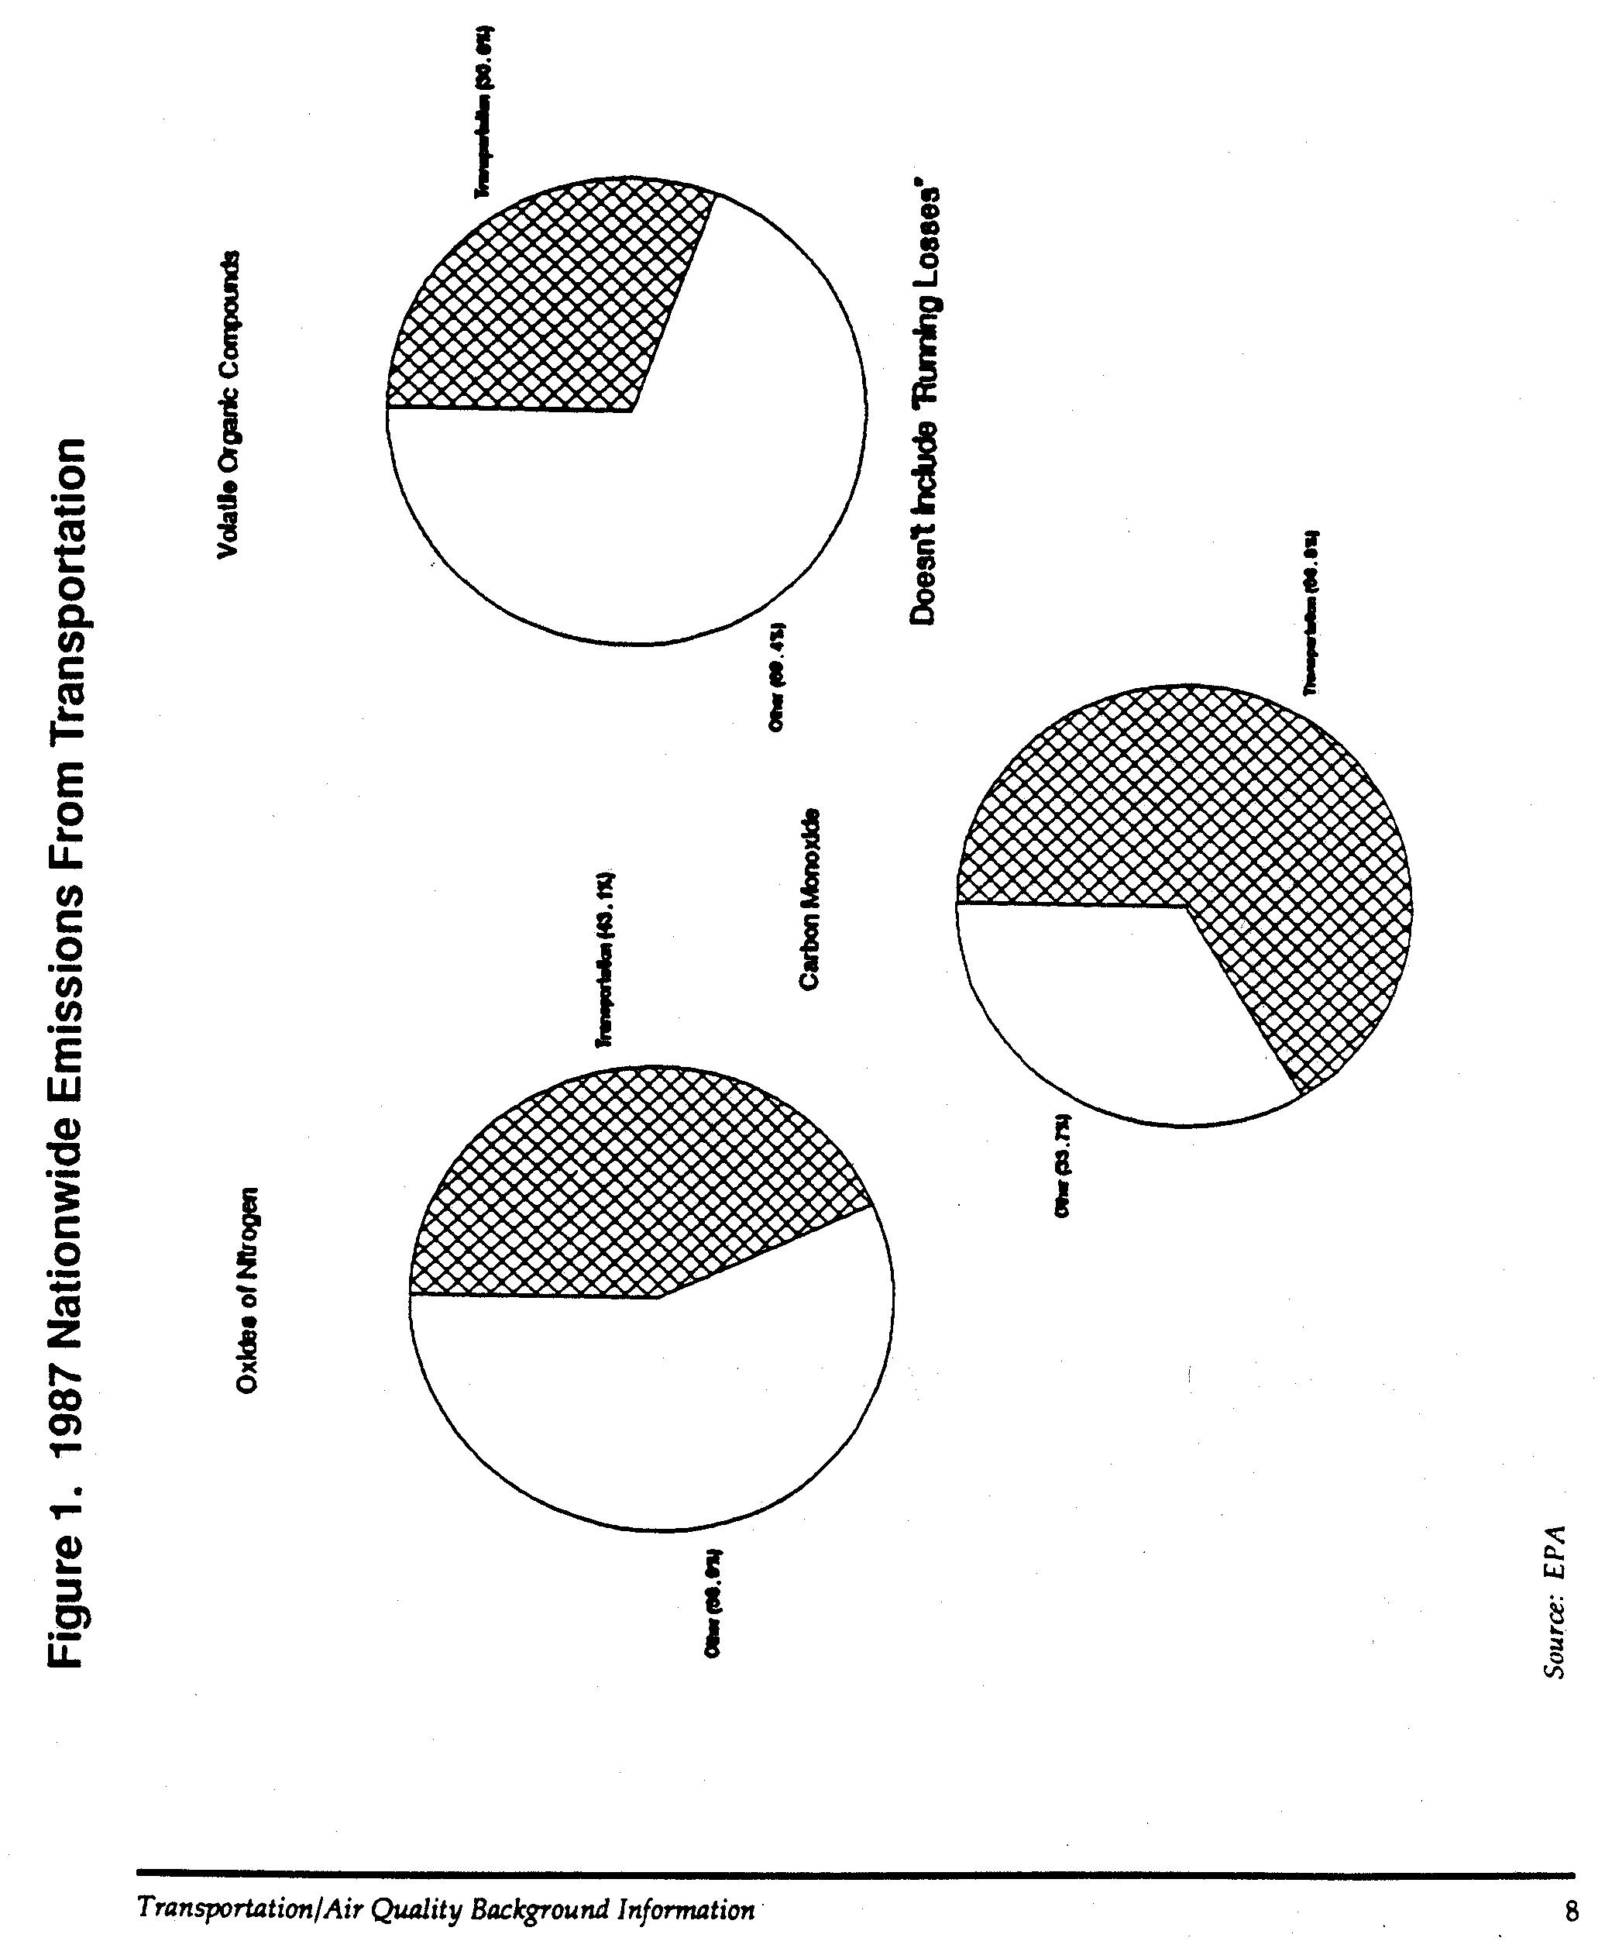
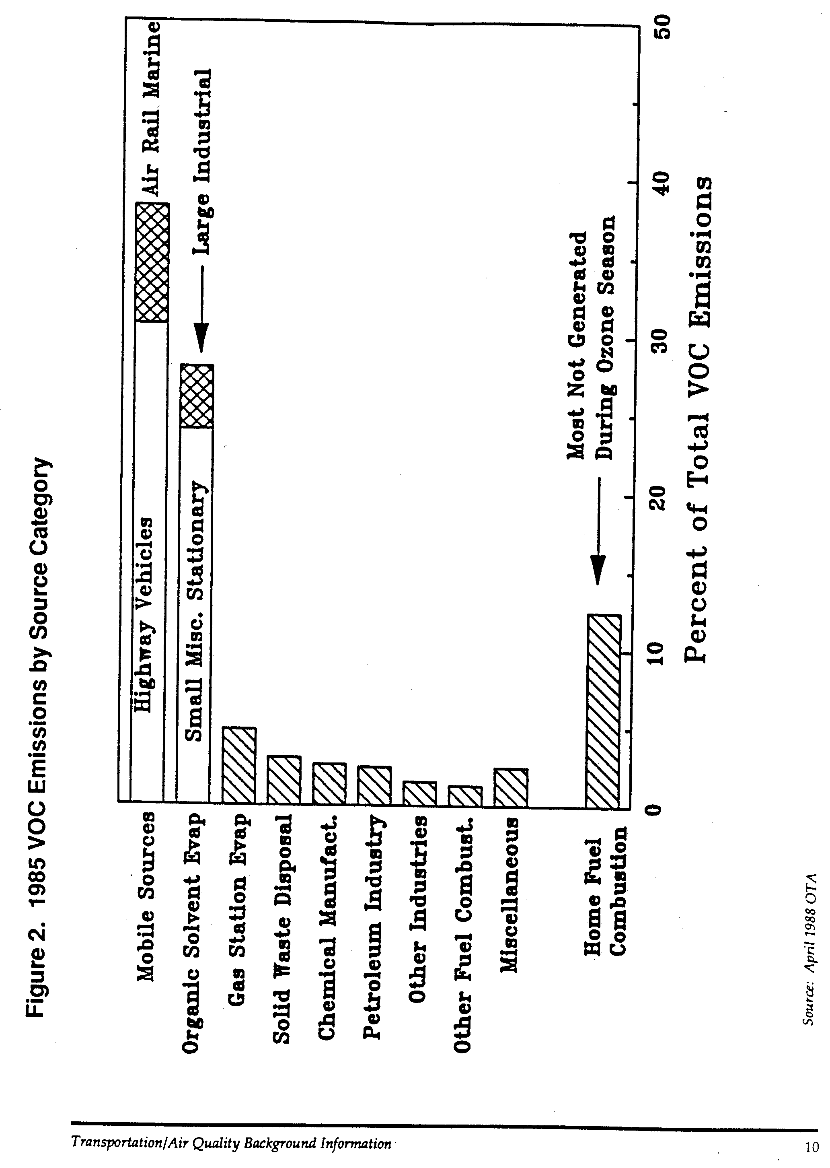
contributes to the production of particulate matter through diesel fuel exhaust, and includes substances such as unburned hydrocarbons, sulfur dioxide, and sulfuric acid. The damaging effect of particulate matter depends on the size of the particle and its composition. Recent studies indicate that particulate emissions can cause respiratory cancer. Beyond their health effects, particulate matter can impair visibility (by absorbing and scattering light) and also cause corrosion and soiling of exposed materials.

Lead is a poisonous heavy metal that damages the nervous system and kidneys. It is also a cause of impaired mental function, particularly among young children. The primary source of lead in the atmosphere is the combustion of gasoline that contains lead antiknock compounds. As a result of the phase-out of leaded fuels, significant progress is being made toward eliminating transportation sources of lead, resulting in a substantial decline in ambient levels of lead.

Contribution of Transportation to Major Environment Problems

Ozone, or O₃, is a colorless gas with a pungent odor. Ozone is not a direct emission from transportation sources. Instead, it is a secondary pollutant formed by photochemical reactions involving HC and NOx in sunlight. Ozone formed naturally in the stratosphere helps filter infrared rays of sunlight, actually protecting the environment from harmful effects of sunlight. However, in the atmosphere, ozone and its related “photochemical oxidants” are referred to as “smog,” which contains a number of compounds which are harmful to living organisms and materials. Ozone is a strong pulmonary irritant which can affect lung functions and cause chest discomfort in sensitive individuals. The effects of ozone are not limited to people with preexisting respiratory problems, but also affect people in good health by producing measurable reductions in normal lung function. It also causes eye irritation, is toxic to plants, damages many materials. Recent studies have demonstrated the damage which ozone causes to forest ecosystems and its impact on the growth of certain crops. Damage to annual crop yield in the U.S. alone has been estimated in the billions of dollars. Almost 80 million Americans currently reside in areas which do not meet the air quality standard for ozone; the problem is so widespread as a result of the long-range transport of ozone that levels of ozone in rural areas can approach levels experienced in urban areas.

Acid rain is the phenomenon of rain, interacting with pollution carried in the air, having greater acid content than natural rain. The deposition of acid rain has adverse effects on aquatic systems, crops, forests, materials, human health, and visibility. In forests, these pollutants fall to earth dissolved in rain and can damage the needles or firs, spruces, and pines, allowing nutrients to escape. They may also acidify the soil, destroying nutrients and fine root systems. Weakened trees become more susceptible to drought, diseases, and insects. Research is continuing to learn more about the causes and effects of acid rain. Transportation emissions which are considered precursors for acid rain formation include VOCs, NOx, and SO₂ . The presence of ozone and other oxidants in the air contribute to converting the precursor SO₂ and NOx into sulfuric and nitric acids which then fall to earth dissolved in rain.

An environmental issue receiving considerable current international attention is global warming or the so-called “greenhouse effect.” Although not currently regulated as a criteria pollutant, carbon dioxide, or CO₂, is a by-product from the burning of fossil fuels. In part, as a result of the burning of fossil fuels such as gasoline, there has been a dramatic increase in the amount of CO₂ in the atmosphere. As a result of its high rate of fossil fuel consumption, the United States if the largest single producer of CO₂ emissions worldwide, with transportation responsible for roughly one-third of all U.S. CO₂ emissions. Scientists believe that increases in the level of CO₂ and other greenhouse gases could change the earth’s climate. Similar to panes of glass in a greenhouse, CO₂ allows solar radiation to enter the earth’s atmosphere but then traps it, preventing heat from escaping into space. As CO₂ levels increase, enough heat may be trapped to warm the atmosphere. Even a slight rise in the earth’s mean temperature could affect rainfall patterns, producing floods and drought. Some scientists even predict the possible melting of the polar ice caps, causing a rise in sea level and potential flooding in numerous cities and farm regions.

Economic Impacts of Air Pollution

Various approaches can be taken to evaluate the economic impacts of air pollution to society. One can assign a monetary value to each of the adverse physical effects of pollution. Or, alternatively, one can determine how much society is willing to pay in order to avoid what are considered the harmful effects of air pollution. Transportation-related emissions have been shown to result in harmful effects on human health, vegetation, materials, and visibility. However, because there are many uncertainties regarding the significance or severity of these effects, it is difficult to place a monetary value on them.

A National Academy of Sciences (NAS) study estimated that a nationwide 90% reduction in auto emissions from 1973 levels would prevent 200 million person days/year of oxidant exposure symptoms and between 800 and 4,400 NO₂-induced deaths/year. The NAS study arbitrarily estimated the value of oxidant exposure symptoms to be between $1 and $10/person day of discomfort and the value of human life to be $200,000 (1973 dollars). As a result, the health benefits of a 90% reduction in auto emissions was estimated to be $0.36-3 billion/year. NAS also estimated that this reduction would prevent between $0.6 and $1.8 billion/year in damage to vegetation and materials. This is equivalent to a total of approximately $1.6-8.8 billion/year in 1980 dollars.

A more recent estimate of the health costs of motor vehicle air pollution has been developed by the Institute of Transportation Studies of the University of California at Berkeley. As part of a 1987 analysis of future transportation fuels, the annual health costs of vehicular air pollution were estimated to be in the range of $4.03 to $84.99 billion, expressed in 1985 dollars.

Other studies based on the willingness of households to pay to improve air quality have determined that households in Boston would be willing to pay from $22 to $470 (1980 dollars) to reduce auto emissions by 90% from 1970-71 levels. Households in Los Angeles would be willing to pay from $110 to $970. (The range of these values illustrates the difficulty in producing estimates based on willingness to pay, especially accounting for the separate influence of transportation pollutants and pollutant concentrations.)

Behavior of Pollution

An important element in understanding how to control pollution is an understanding of how various factors affect the accumulation of pollution in the environment. These factors include the rate of emission, proximity of the source to receptors, and various external factors such as temperature, wind speed, and topography. Depending upon the specific pollutant, these variables can affect the production and accumulation of pollution differently.

Concentrations of CO, O₃ and NO₂, the major transportation-related pollutants, are sensitive to emissions rates of the primary pollutants, the proximity of receptors to sources of primary pollutant emissions, and meteorological conditions. However, the degree of sensitivity varies significantly. These variables and their effect on the behavior of pollution imply that different approaches are needed to control emissions of each pollutant.

Carbon Monoxide

The concentration of CO at a given location is primarily a function of the rate of emissions from nearby CO sources; meteorological variables such as wind speed and direction and atmospheric turbulence; and topographical features. CO concentrations are higher near congested roadways and high traffic locations and decrease rapidly as distances from these traffic sources increase. Furthermore, CO concentrations tend to be consistent with daily variations in traffic volume, having their highest levels during peak traffic periods when traffic volumes and congestion are greatest and average travel speeds are slowest. NAAQS are established for both 1-hour and 8-hour averaging periods for CO to account for peak period conditions when CO levels are highest and for longer term exposure to more persistent concentrations of CO.

Meteorological variables, however, can moderate the influence of traffic and cause large fluctuations in CO concentrations, even if the volume of CO emissions is unchanged. Topographical factors, such as the proximity of tall buildings or the depression of a roadway below grade, further affect CO concentrations by affecting the patterns in which air circulates. As a result, CO concentrations at a given location can vary widely depending upon the time of day, or, at the same time of day, can vary widely between two nearby locations.

There is a strong linear relationship between CO concentrations and traffic volumes, with high traffic volumes producing high CO levels. Furthermore, as vehicle speeds decrease, CO emissions rates increase. Therefore, CO concentrations tend to be higher to proximity to congested urban roadways and intersections than near locations where traffic flows freely.

Wind direction is also significant because the concentration of a pollutant is higher downwind of the emissions source than upwind. Increases in wind speed means a greater volume of air passes an emissions source during a fixed unit of time, thereby reducing pollutant concentrations. As a result, it is possible to have high traffic volumes without significant CO concentrations if high wind speeds are present, causing wider dispersion and mixing of the air mass in proximity to the pollutant source. Conversely, low wind speeds and reduced levels of atmospheric turbulence produce stable conditions in which mixing of air masses is limited, resulting in higher concentrations of pollutants.

Automobiles emit higher volumes of CO in cold weather than in warm weather, due to combustion characteristics of internal combustion engines. However, because winds tend to be higher in winter than in fall, the highest measured concentrations of CO tend to be in the fall, when stable atmospheric conditions tends to reduce dispersion of emissions.

Because of the localized nature of CO concentrations, most control strategies are oriented toward alleviation of high traffic volumes and congestion at specific locations, known as “hot spots.” Typically, a hot-spot strategy involves improvements to traffic flow at a location experiencing unusual traffic congestion on high traffic volumes. This could involve simply the retiming of a traffic signal or the redirecting of traffic to alternate routes. However, as more is learned about the nature of CO violations, CO is increasingly being viewed as an area wide problem, requiring broader-based strategies oriented toward the transportation network as a whole. In this way, by alleviating a traffic problem at a single location, the CO problem would not be transferred to another location as result of traffic being redirected to different roads or intersections.

Ozone

The most important factor affecting the behavior of ozone is that it has no single emissions source, but is instead a secondary pollutant for which excessive concentrations in the lower atmosphere are the result of chemical reactions involving “precursor” emissions of HC and NOx. As a result, unlike CO, the relationship between emissions of HC and NOx, and pollutant concentrations of O₃ is nonlinear. Also, unlike CO, spatial variations in O₃ are more gradual. If O₃ levels are excessive at any given monitoring site, they will generally be excessive over a large area, possibly covering an area encompassing hundreds or thousands of square miles.

O₃ concentrations, like CO, are sensitive to meteorological variables such as wind speed and direction, atmospheric stability, and temperature. A further important meteorological variable is the intensity of solar radiation which contributes to the photochemical reaction. O₃ concentrations increase with increased solar intensity. The relationship
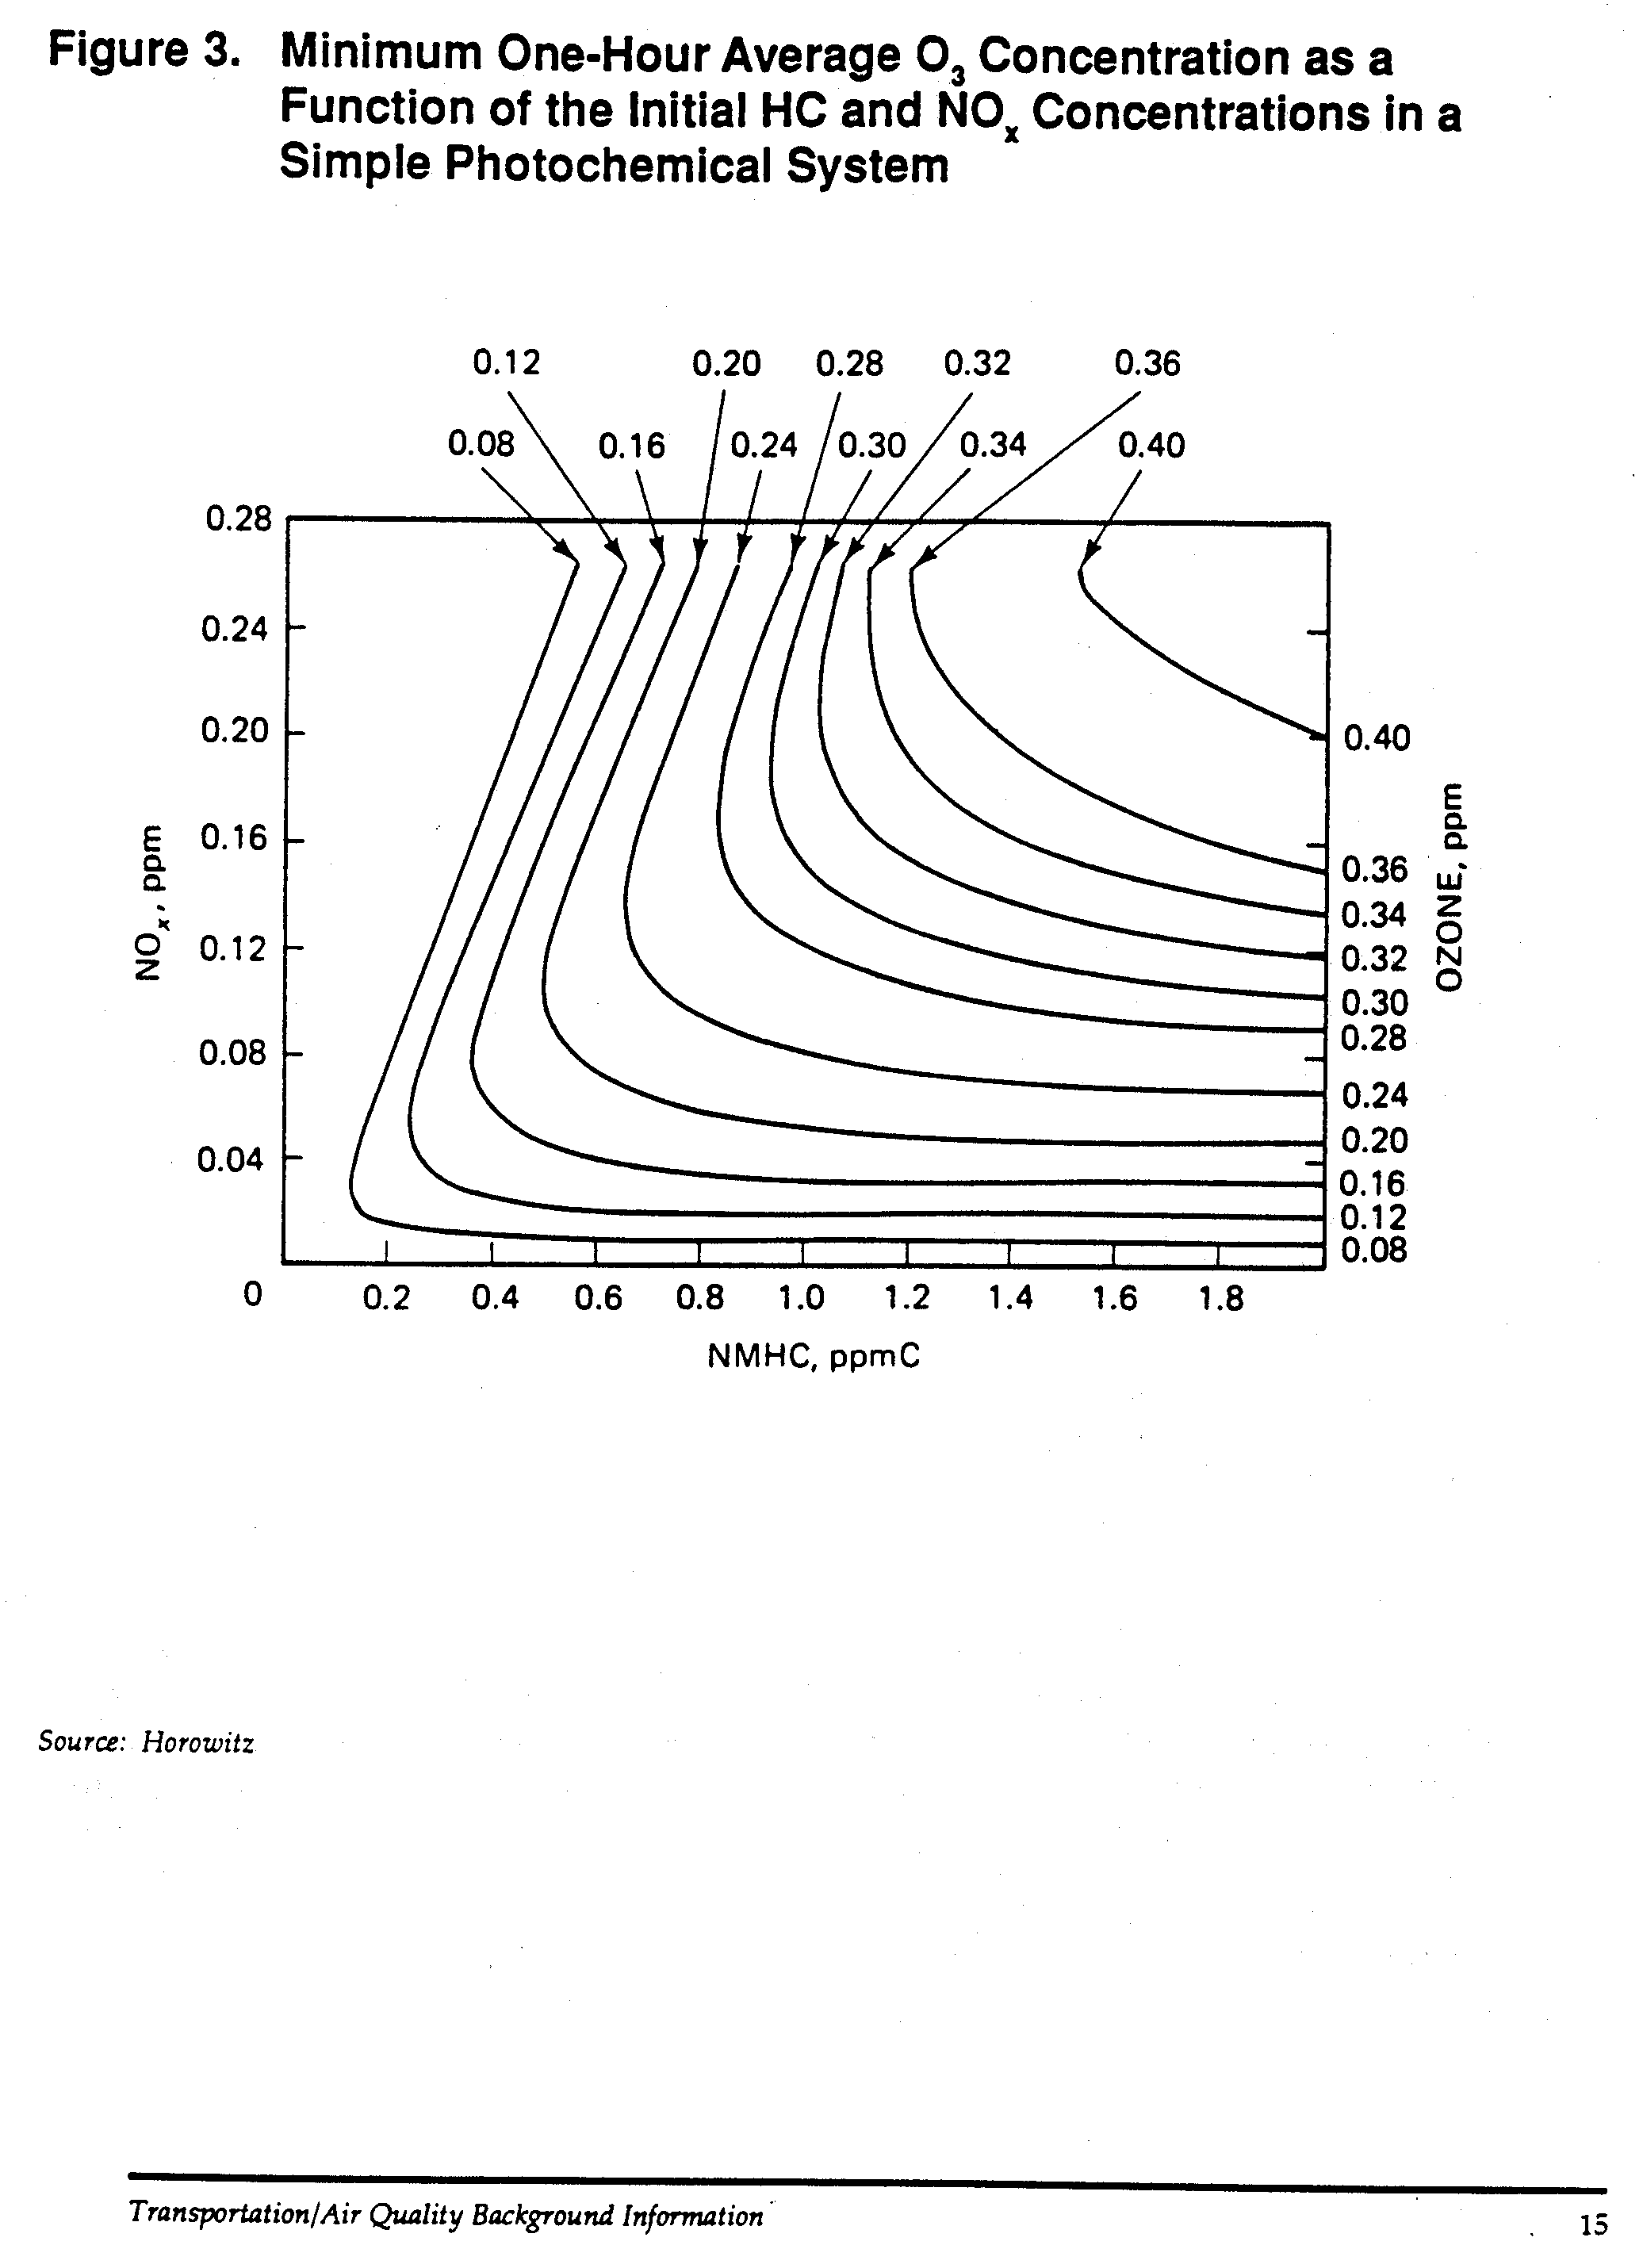
between these precursors and concentrations of O₃ is highly complex but as indicated in Figure 3, reductions in precursor emissions do not necessarily cause a reduction in maximum O₃ levels. There is, in fact, no proportional relationship between concentrations of precursors and O₃ levels.

The formation of O₃ takes place over periods ranging from several hours to several days, depending upon meteorological conditions. Mixing and wind movement over these periods cause emissions from a large number of HC and NOx sources distributed over a large area to be combined into the same air mass. As a result, high O₃ concentrations generally cannot be attributed to individual HC or NOx sources.

The chemical reactions that form O₃ and the role of sunlight in driving the reactions result in diurnal variations in O₃ concentrations. O₃ concentrations tend to peak during the late morning or early afternoon hours in many cities. Chemically, this appears to be a result of the amount of time required for the chemical reactions to occur. However, meteorological conditions cause the “transport” of polluted air masses over time into areas where additional precursors are produced, causing the chemical reaction process to continue. Wind speed and turbulence also affect the ways in which precursors are dispersed, affecting overall concentrations of O₃. Seasonal variations in meteorological conditions, particularly solar intensity and temperature, produce seasonal variations in O₃ levels. As shown in Figure 4, high ozone levels are directly related to higher ambient temperatures. A number of large scale regional ozone studies are currently underway to model the behavior of this complex pollutant in order to identify the interactive nature of ozone precursors and atmospheric conditions.

Atmospheric mixing and movement during the formation of O₃ can cause O₃ concentrations to be high at large distances from the sources of the O₃ precursors. O₃ can become “trapped” in the atmosphere and be transported for long distances. As a result, high concentrations of O₃ have measured in rural areas located far from the source of precursor emissions. For example, O₃ violations have been annually recorded at Arcadia National Park on the coast of Maine. As a result, unlike CO, due to the spatial characteristics of O₃ , control programs for O₃ must be designed on at least a metropolitan scale to be effective.

Nitrogen Oxides

Man-made NOx emissions consist of both NO and NO₂, of which NO accounts for 90-95% of the total. Although NO₂ itself is produced as a primary pollutant, its high concentrations in the atmosphere are caused by the oxidation of NO to NO₂ through the chemical reactions that also produce O₃. Atmospheric mixing during the formation of NO₂ tends to cause NO₂ concentrations to be dispersed from large NO sources. However, there can also be sharp peaks in NO₂ levels near NO sources such as the downwind side of busy highways. Because of the areawide nature of NOx emissions, control strategies are generally designed at the metropolitan or regional level.

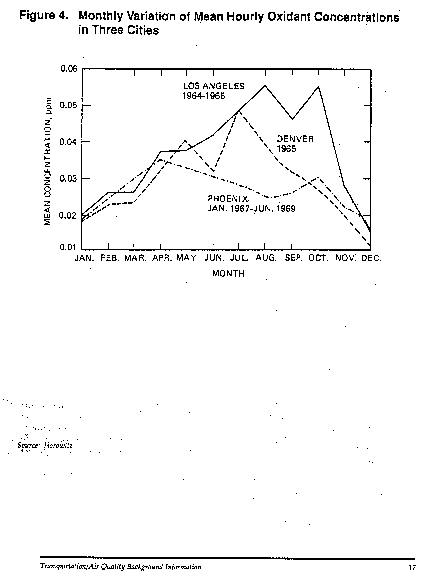
Similar to O₃, No₂ concentrations decrease with higher wind speeds and turbulence and increase with higher temperatures. However, the relationship of NO₂ to the intensity of solar radiation is more complex. Although sunlight is needed in the photochemical reactions that produce NO₂, sunlight also can destroy NO₂ by a process of photolysis. Therefore, solar intensity can either increase or decrease NO₂ concentrations, depending upon its intensity and the stage of the chemical reaction process.

Daily and seasonal variation in NOx concentrations are somewhat difficult to characterize and appear to be inconsistent in different cities. In areas of significant photochemical activity, NO₂ levels generally peak in mid-morning and early evening. The extent of the peaking appears to be influenced by meteorological factors and by the extent of O₃ generated during the day. On days with limited photochemical activity, indicated by limited production of O₃, NO₂ peaking is less evident. Although NO concentrations vary seasonally in various cities in similar patterns, NO₂ concentrations do not exhibit the same consistency. In general, NO concentrations are higher in winter but NO₂ concentrations do not exhibit the same consistency. In general, NO concentrations are higher in winter but NO₂ concentrations can peak in either the summer or winter, depending upon the city being analyzed. This is due to the sensitive relationship between meteorological factors and photochemical activity.

NO₂, like O₃, can be carried in urban smog plumes. However, NO₂ concentrations decrease quickly downwind of urban areas and approach background levels in relatively short distances from theses areas. This is due to the chemical conversion of NO₂ into other compounds. As a result, NO₂ concentrations are generally low in rural areas, even if O₃ concentrations are high.

Sources of Pollutant Emissions

Categories of Emissions Sources

Air pollutants are produced by numerous sources of emissions which can be categorized in various ways. Emissions sources generally are classified as point, area, or line sources, depending upon their magnitude and geographic distribution. A point source is a large, concentrated source of emissions such as a coal-fired power plant. An area source is a collection of smaller, dispersed emission sources which, individually, are insignificant, but are significant collectively. Examples include residential and commercial space heaters or the overall street system of a city. Line sources generate emissions more or less uniformly along a line, such as an urban highway. Air pollution source can also be defined more broadly as “stationary,” i.e. from a fixed location, or “mobile,” meaning transportation-related. Mobile or transportation sources include highway vehicles, off highway vehicles, aircraft, railroad locomotives, and marine vessels. The focus of theses Information Documents is on emissions from highway vehicles.

Highway-Related Sources

Highway-related mobile sources of air pollutants include a wide range if vehicle types, each with unique characteristics relevant to the categories and volume of pollutants which are produced. Key variables include the age of the vehicle and the type of fuel which is utilized. The category of emissions generated by mobile sources differentiates between highway vehicles and off-highway vehicles. Off-highway sources include sources such as farm equipment, industrial and construction sites, and recreational vehicles.

For the purpose of analyzing or regulating highway vehicle emissions, the following vehicle classes are generally used:

- Light-duty gasoline fueled vehicle

- Light-duty gasoline fueled trucks

- Heavy-duty gasoline fueled vehicles

- Light-duty diesel vehicles

- Light-duty diesel trucks

- Heavy-duty diesel vehicles

- Motorcycles

Each of these vehicle classes has its own emissions characteristics and its own set of emissions standards. The new 1990 Clean Air Act motor vehicle emission standards are shown in Table 2, with the complete set of new tailpipe emission standards provided as Table 3. The CO standard of 3.4 grams/mile is retained; a new cold temperature (20 degrees F) CO standard of 10 grams/mile, however, is defined beginning with 1994 models. The HC standard is reduced from .41 to .25 grams/mile and the NOx standard is reduced from 1.0 to 0.4 grams/mile. The new tailpipe emission standards are phased in over time. In 1994, 40% of the vehicles sold must comply with the new standard. By 1996, all new vehicles sold must attain theses lower emission limits. Light-duty gasoline fueled vehicles, or automobiles, comprise the largest source of transportation-related pollutants, due to their widespread use. Passenger cars alone currently account for nearly 20% of Volatile Organic Compound (VOC) emissions produced by mobile and stationary sources combined (Walsh, 1988 – Fig. 33). The California Air Resources Board estimates that cars and trucks contributed 43% of all HC, 57% of all NOx, and 82% of all CO in the major urban areas of California in 1987.

Production of Highway Vehicle Emissions

Vehicles produce emissions both through the combustion process and through evaporation of fuel and lubricants. Emissions from conventional gasoline-powered vehicles are generated from 3 sources: the crankcase, the fuel system, and the exhaust. The crankcase and fuel system are sources of hydrocarbons; exhaust is a source of hydrocarbons, carbon monoxide, and NOx. There are three distinct phases of vehicle operation, during which vehicles emit differing levels of pollutants: the cold start mode, the hot soak evaporative mode, and the hot stabilized mode. Cold start emissions occur during the first few minutes of operation when the vehicle and its catalytic converter are cold. Hot soak emissions occur when a previously operated vehicle is parked and the hot engine causes gasoline still in the carburetor or fuel system to evaporate or “boil off.” Evaporative emissions of hydrocarbons occur whenever fuel is exposed to the air although there are a number of processes at work. Fueling emissions occur when fuel entering the fuel tank displaces fuel vapors into the air. Diurnal losses occur as a result of diurnal temperature variations on the fuel and fuel vapors in the fuel tank. In the hot stabilized mode, after the engine and catalytic converter have warmed up to normal operating temperature, running exhaust emissions are produced as the vehicle is operated.

During engine operation, some of the gases in the engine cylinders escape past the pistons and enter the crankcase, producing “blow-by” emissions. These gases consist, in large part, of unburned gasoline, primarily HC. Fuel system emissions are due to evaporation and the refueling process, also producing HC. Crankcase emissions account for approximately 20% of the HC emissions from automobiles without emissions controls. Normal warming processes on warm days, by causing the expansion of fuel and fuel vapors in the fuel tank, causes diurnal evaporation. Emissions from the carburetor occur while the engine is still hot from recent operation. The fuel left in the carburetor is hot and can evaporate rapidly. Excluding fueling losses, evaporation from the fuel system accounts for another 20% of the HC emissions from uncontrolled automobiles. Some estimates of the relative total volume of evaporative emissions indicate that they can be responsible for as much as one-third of total hydrocarbon emissions from gasoline fuel vehicles. Exhaust emissions controls, approximately 60% of HC emissions.

The volume of running exhaust emissions are a function of the length and speed of a given trip, although relatively low levels of pollution are emitted for each mile driven. Due to the high volume of emissions produced during cold start and hot soak phases, a 5 mile trip produces nearly the same volume of hydrocarbon emissions as a 10 mile trip (Figure 5). Regardless of distance, the volume of trip end emissions remains the same. This points out the fact that it is as important to reduce the total number of trips as it is to reduce their distance. Traffic congestion, on the other hand can have a significant bearing on total running emissions. Air pollution increases as a direct result of increased vehicle hours of operation due to delays in traffic. For example, a 10-mile trip taking 30-minutes produces 350% more running exhaust
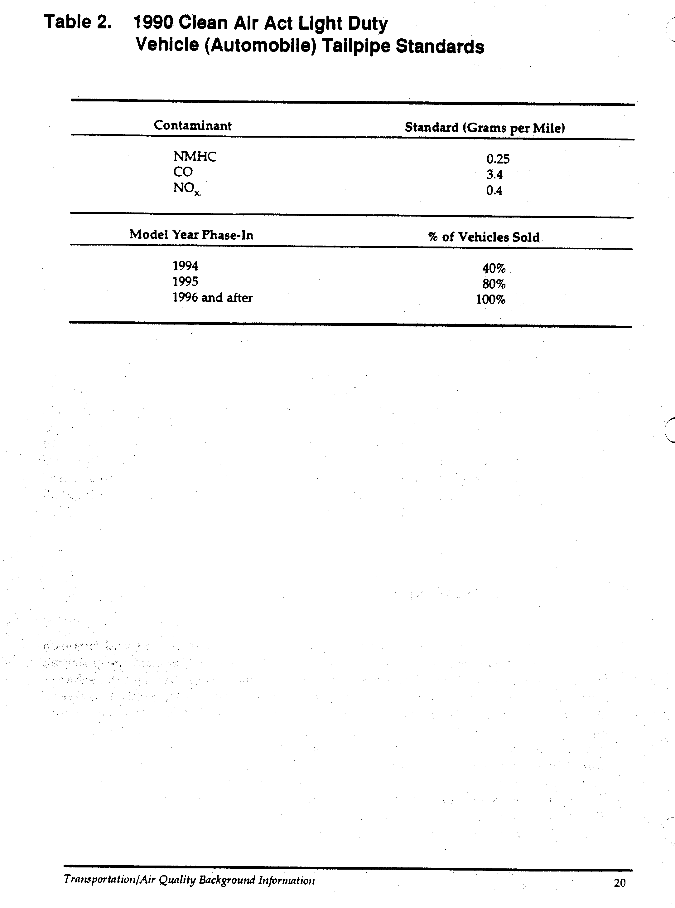
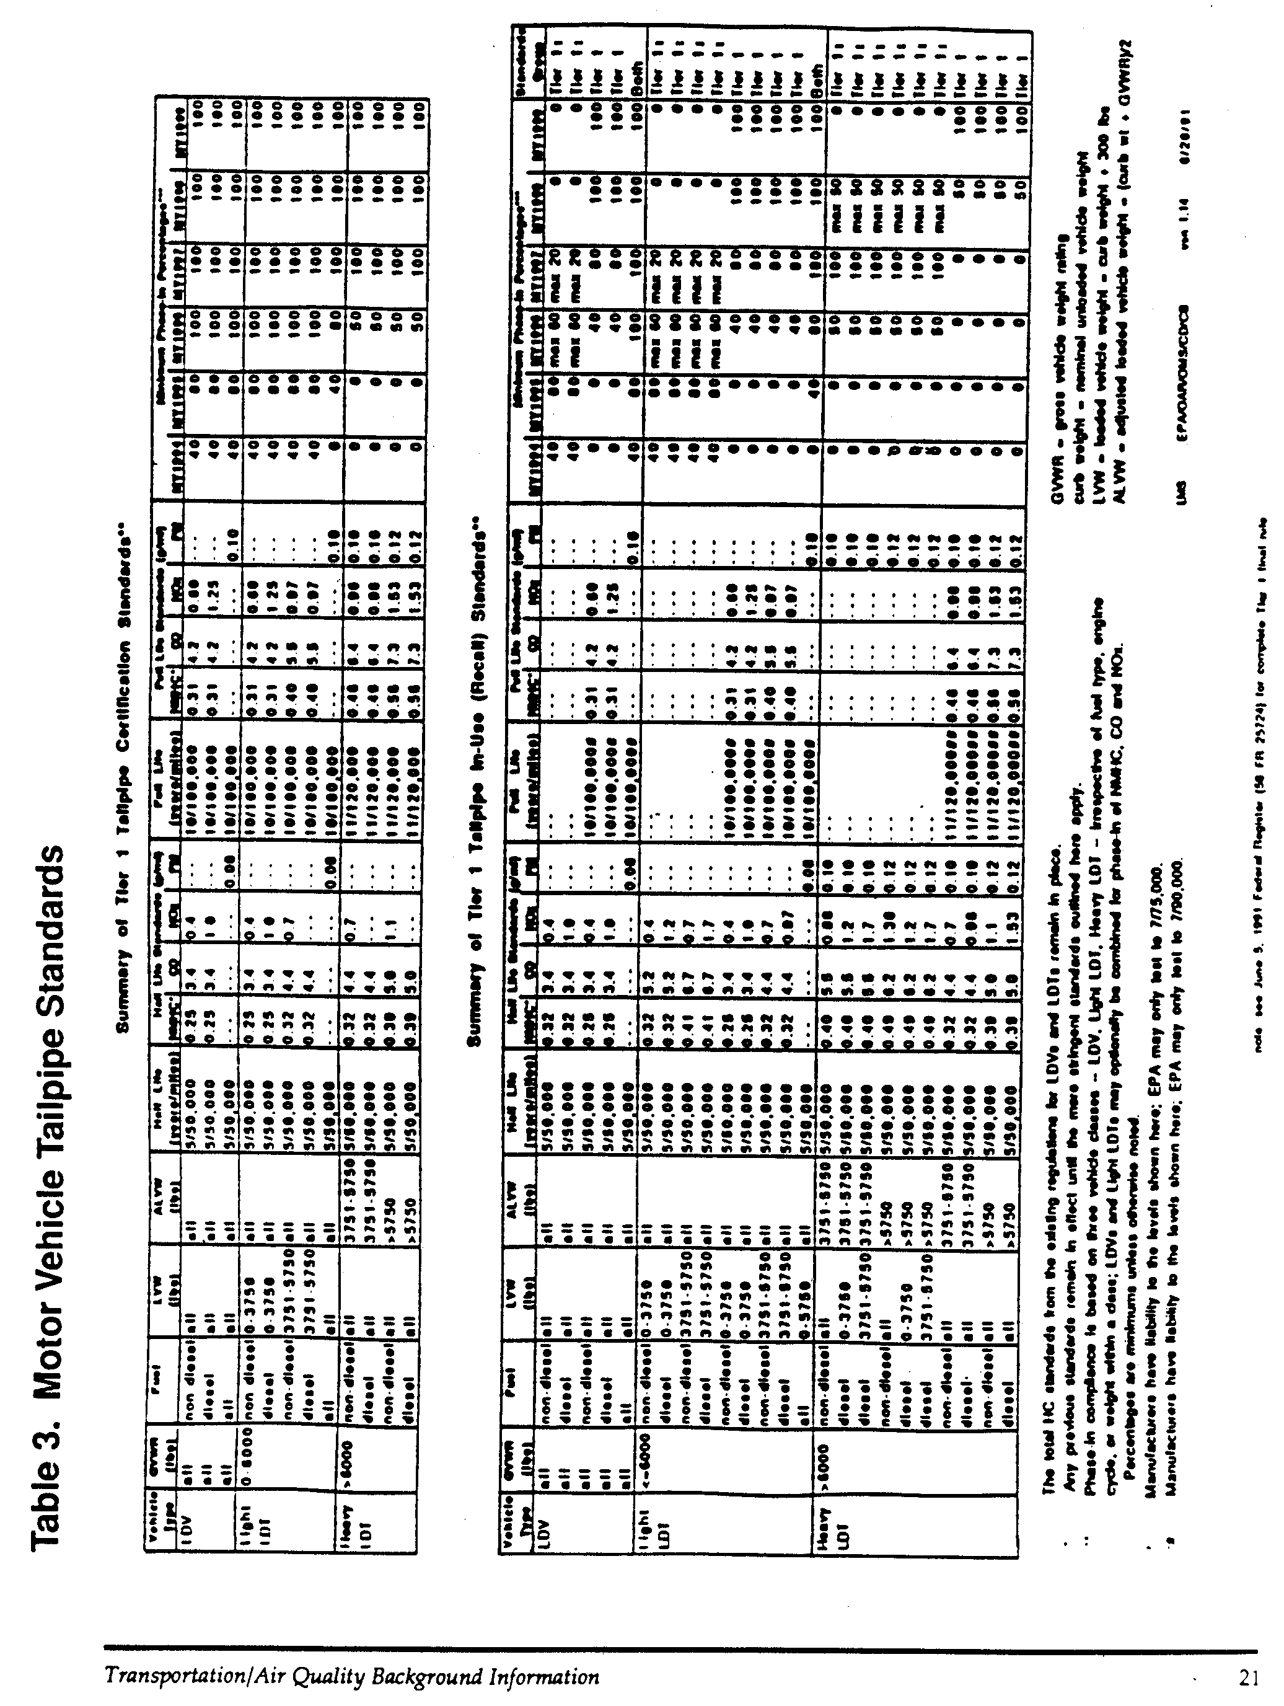
HC emissions than the same trip if it were to take 11-minutes. Given a trend toward increasing congestion nationwide, this has serious implications for the ability of many areas to meet air quality standards for transportation-related emissions.

Variables Affecting Vehicle Emission Rates

Specification of Keys Variables

Temperature
Fuel tends to not vaporize well in a cold engine. As a result, unburned or partially burned fuel passes through the engine and into the exhaust. Furthermore, catalytic converters do not function well when they are cold. As a result, vehicles in the cold start phase of operation have higher HC and CO emissions and lower fuel economy than warmed-up vehicles. The temperature of an engine during a cold start is generally the same as the temperature of the surrounding air. Therefore air temperature directly affects the magnitude of cold start emissions. Decreases in the air temperature cause an increase in these emissions which is particularly apparent in vehicles equipped with catalytic converters. Temperature is a critical variable in the production of CO emissions. Most violations of the CO standard occur during wintertime, at temperatures below 50 degrees F.

Vehicle Age and Maintenance
As a vehicle ages, there is an increase in the wear and deterioration of engine parts and emission controls. Over the life of a vehicle, wear and deterioration of engine parts and emission control equipment can cause emissions to increase. Prior to passage of the 1990 Amendments, for most passenger vehicles on the road today automotive emission control equipment was covered by a manufacturer’s warranty for the first 50,000 miles of operation or 5 years, whichever occurs first. Under the 1990 Clean Air Act Amendments, separate vehicle emission standards are specified for certification or warranty at 100,000 miles or 10 years. These are 0.31, 4.2 and 0.6 grams per mile for NMHC, CO, and NOx respectively. The increase in both mileage and time recognizes the practical useful life of vehicles on the road today. Over a vehicle’s full lifetime, emissions levels can be far in excess of current standards and there is considerable concern today with so-called superemitters; i.e., a small percentage of vehicles causing a disproportionate large percentage of highway vehicle emissions.

Proper vehicle maintenance can significantly reduce the increase in emissions as a vehicle ages but cannot guarantee that a vehicle will not exceed standards over time. Maintenance practices vary greatly between owners. What is considered normal maintenance is not necessarily proper maintenance. Data from tests conducted by EPA
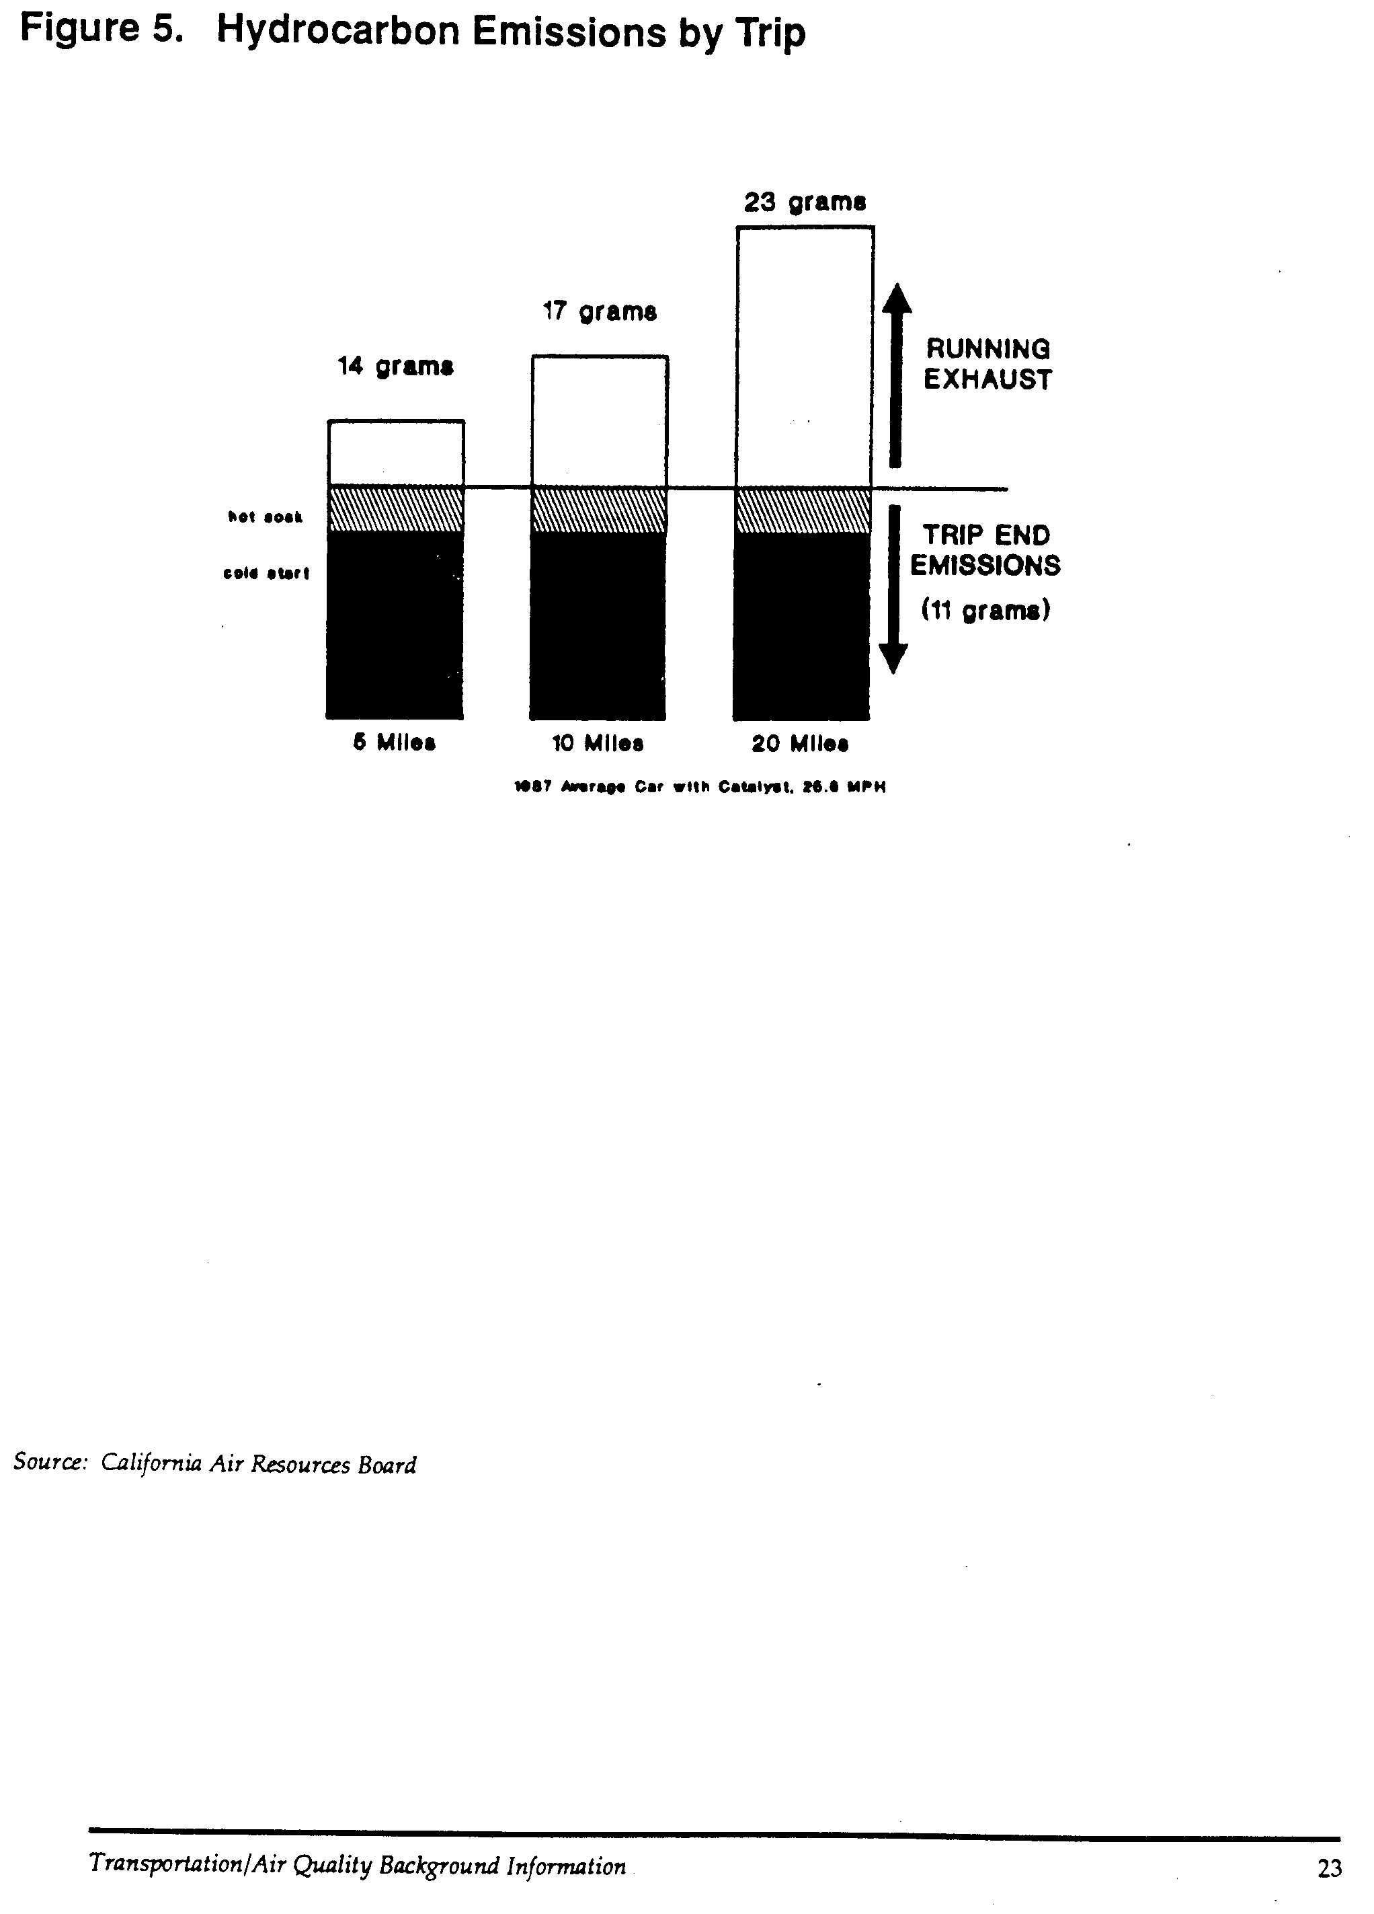
on in-use vehicles show that properly maintained vehicles increasingly exceed their standards the longer their operating life, and that normally maintained vehicles produce significantly higher levels of emissions.

Speed
The rate at which emissions are produced is directly related to the speed at which a vehicle is operating (Figure 6). The frequency of acceleration and deceleration for an operating vehicle, particularly a vehicle operating in congested conditions, can also significantly affect the rate of emissions. Carbon monoxide and HC emissions are higher at slower speeds, especially below 20 mph, which are typical speeds on urban streets and congested highways. It is important to understand that the relationship between vehicle speed and emissions is non-linear, that is, at speeds below 20 mph, emission rates increase at a greater rate as speeds continue to decrease. NOx, on the other hand, decreases with reductions in vehicle speed. Recent evidence indicates that CO and HC emissions may once again increase with vehicle speeds above 50 mph.

Relative Importance of Key Variables on Emissions Rates

EPA has estimated the sensitivity of emissions to the many variables that affect their rate of production by applying variable input data in MOBILE4, EPA’s mobile source emission factor model (Figure 7). Comparisons were made between standardized emission inventories, using variable conditions relative to speed, temperature, proportion of hot and cold starts, mileage accumulation, and average age of the vehicle fleet. Separate analyses were performed under summer and winter conditions, for NMHC, CO, and NOx.

Under summer conditions, as speed decreases from the Federal Test Procedure (FTP) average of 19.6 mph, the increase in emissions of NMHC becomes more non-linear. The effect of a highly congested speed of 7.1 mph produces an 83% increase in emissions. At speeds above 19.6 mph, the impact is much less significant. Changes in temperature, above and below the FTP value of 75 degrees F also causes an increase in NMHC, although not as significant as those observed from speed variations. The effect of variation in the average age distribution of the fleet also has a significant bearing on NMHC production. Older vehicles may have lower levels of annual travel than newer vehicles, but also produce more emissions per mile. Emissions of NMHC are highly sensitive to changes in the age composition of the fleet. On the other hand, variation in the proportion of hot and cold starts does not appear to be as significant a variable.

CO emission levels appear to be subject to the same trends as NMHC, although the magnitude of sensitivity to changes in speed and temperature is much greater. While it is known that CO emissions increase with lower ambient temperatures, high temperatures (for this analysis, 95 degrees F was used) also produced increased CO emissions. A wintertime analysis of CO emission variable also was conducted which showed even higher levels of CO production occur when speeds are reduced, in comparison to summer operating conditions.
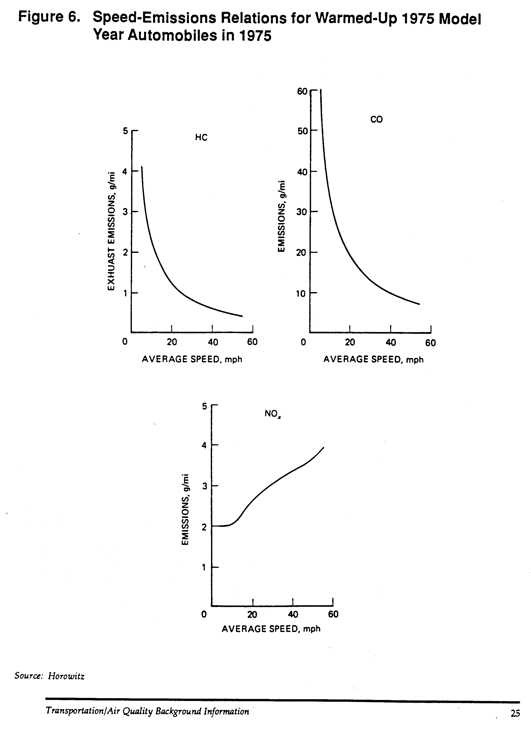
NOx emissions exhibit a different pattern than NMHC and CO. NOx is relatively insensitive to changes in speed and decreases in temperature. However, increases in temperature produce significant reductions in emissions.

Available Control Technologies

There are basically two ways in which vehicle emissions can be controlled. One way is to manage emissions at their source. That is reduce emissions from the vehicle by controlling the way in which the vehicle produces emissions (Figures 8, 9). This includes various mechanical control technologies such as catalytic converters, recirculation of exhaust gases, and evaporative controls. An important aspect of the ability of this technology to reduce emissions is the monitoring of emission control equipment to assure that it is functioning properly. This control technology also includes measures to control emissions at the gas pump during refueling, as well as improvements in the composition of the fuel itself. These technologies also include the use of alternative fuels.

A second approach to managing emissions produced by motor vehicles is to manage how the vehicle itself is used. This includes measures to reduce both total trips and total vehicle miles traveled, including measures to assure that while in use a vehicle is used as efficiently as possible.

On-Board Controls and New Car Standards

On-board controls and new car standards are approaches to controlling emissions which depend primarily on automotive technology. Since the early 1960’s, new motor vehicles sold in the U.S. have been subject to increasingly stringent emissions control requirements. These requirements regulate both exhaust and evaporative emissions. To comply with these requirements, automakers have made extensive technological improvements through innovations in vehicle design and operations, and by the installation of emissions control devices on vehicles.

The EPA enforces these standards through the testing of prototype vehicles prior to their production by sampling vehicles taken from the assembly line. Under the Clean Air Act, vehicles are protected from defects in emissions control equipment by a manufacturers warranty for a period established by EPA. Once vehicles are sold, they are subject to manufacturers’ recalls if defects in emissions control systems develop.
Although emission control technology varies between automakers and by vehicle models, certain equipment is common to most gasoline engine vehicles. The most commonly recognized emissions control device is a catalytic converter. When heated to a high temperature, metals within the catalytic converter, such as platinum, create a chemical reaction which converts hydrocarbons and CO from engine exhaust into CO₂ and water. Catalytic converters and improvements to gasoline have, in combination, reduced emissions from modern automobiles by about 95% compared to the lowest-emitting models of 20 years ago. Other control technology includes “positive crankcase ventilation” (PCV) systems which aid in the recirculation of crankcase emissions, evaporative emissions controls which collect evaporative emissions from the fuel system in a canister, and exhaust gas recirculation systems. Most new cars also utilize microcomputer technology which controls and coordinates ignition and fuel systems, as well as the operation of emission control equipment, to minimize exhaust emissions under varying
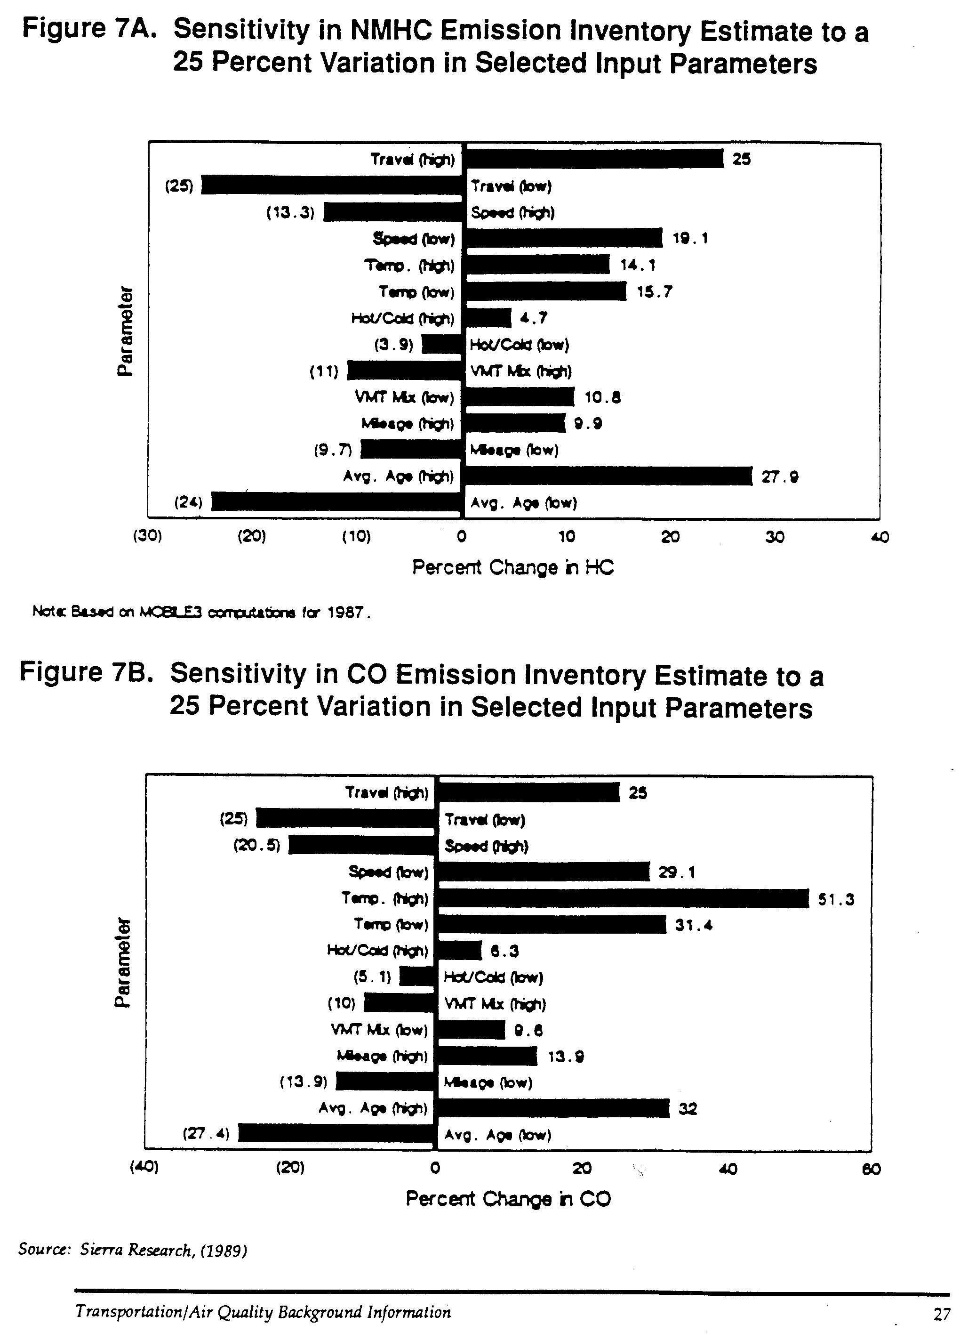
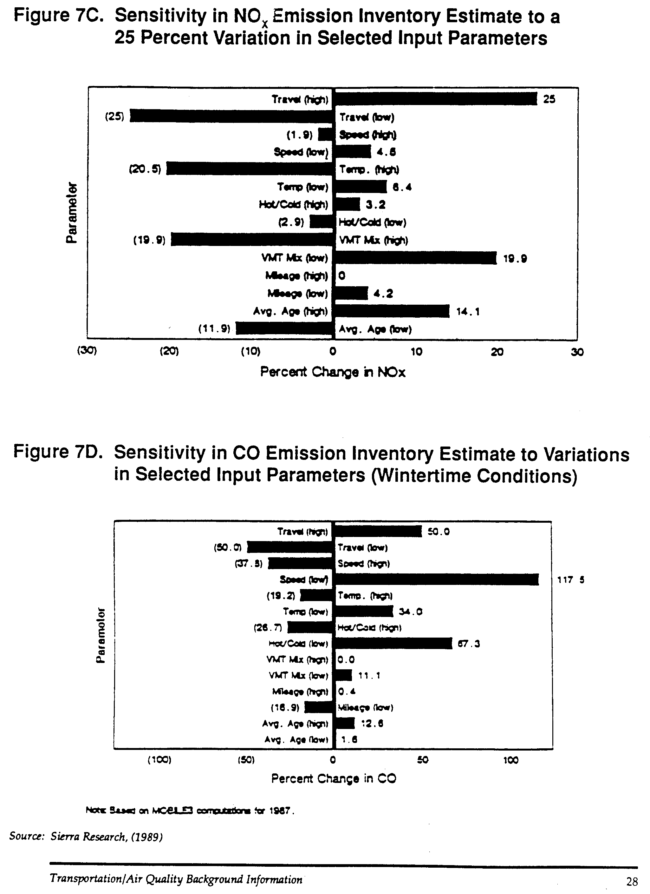
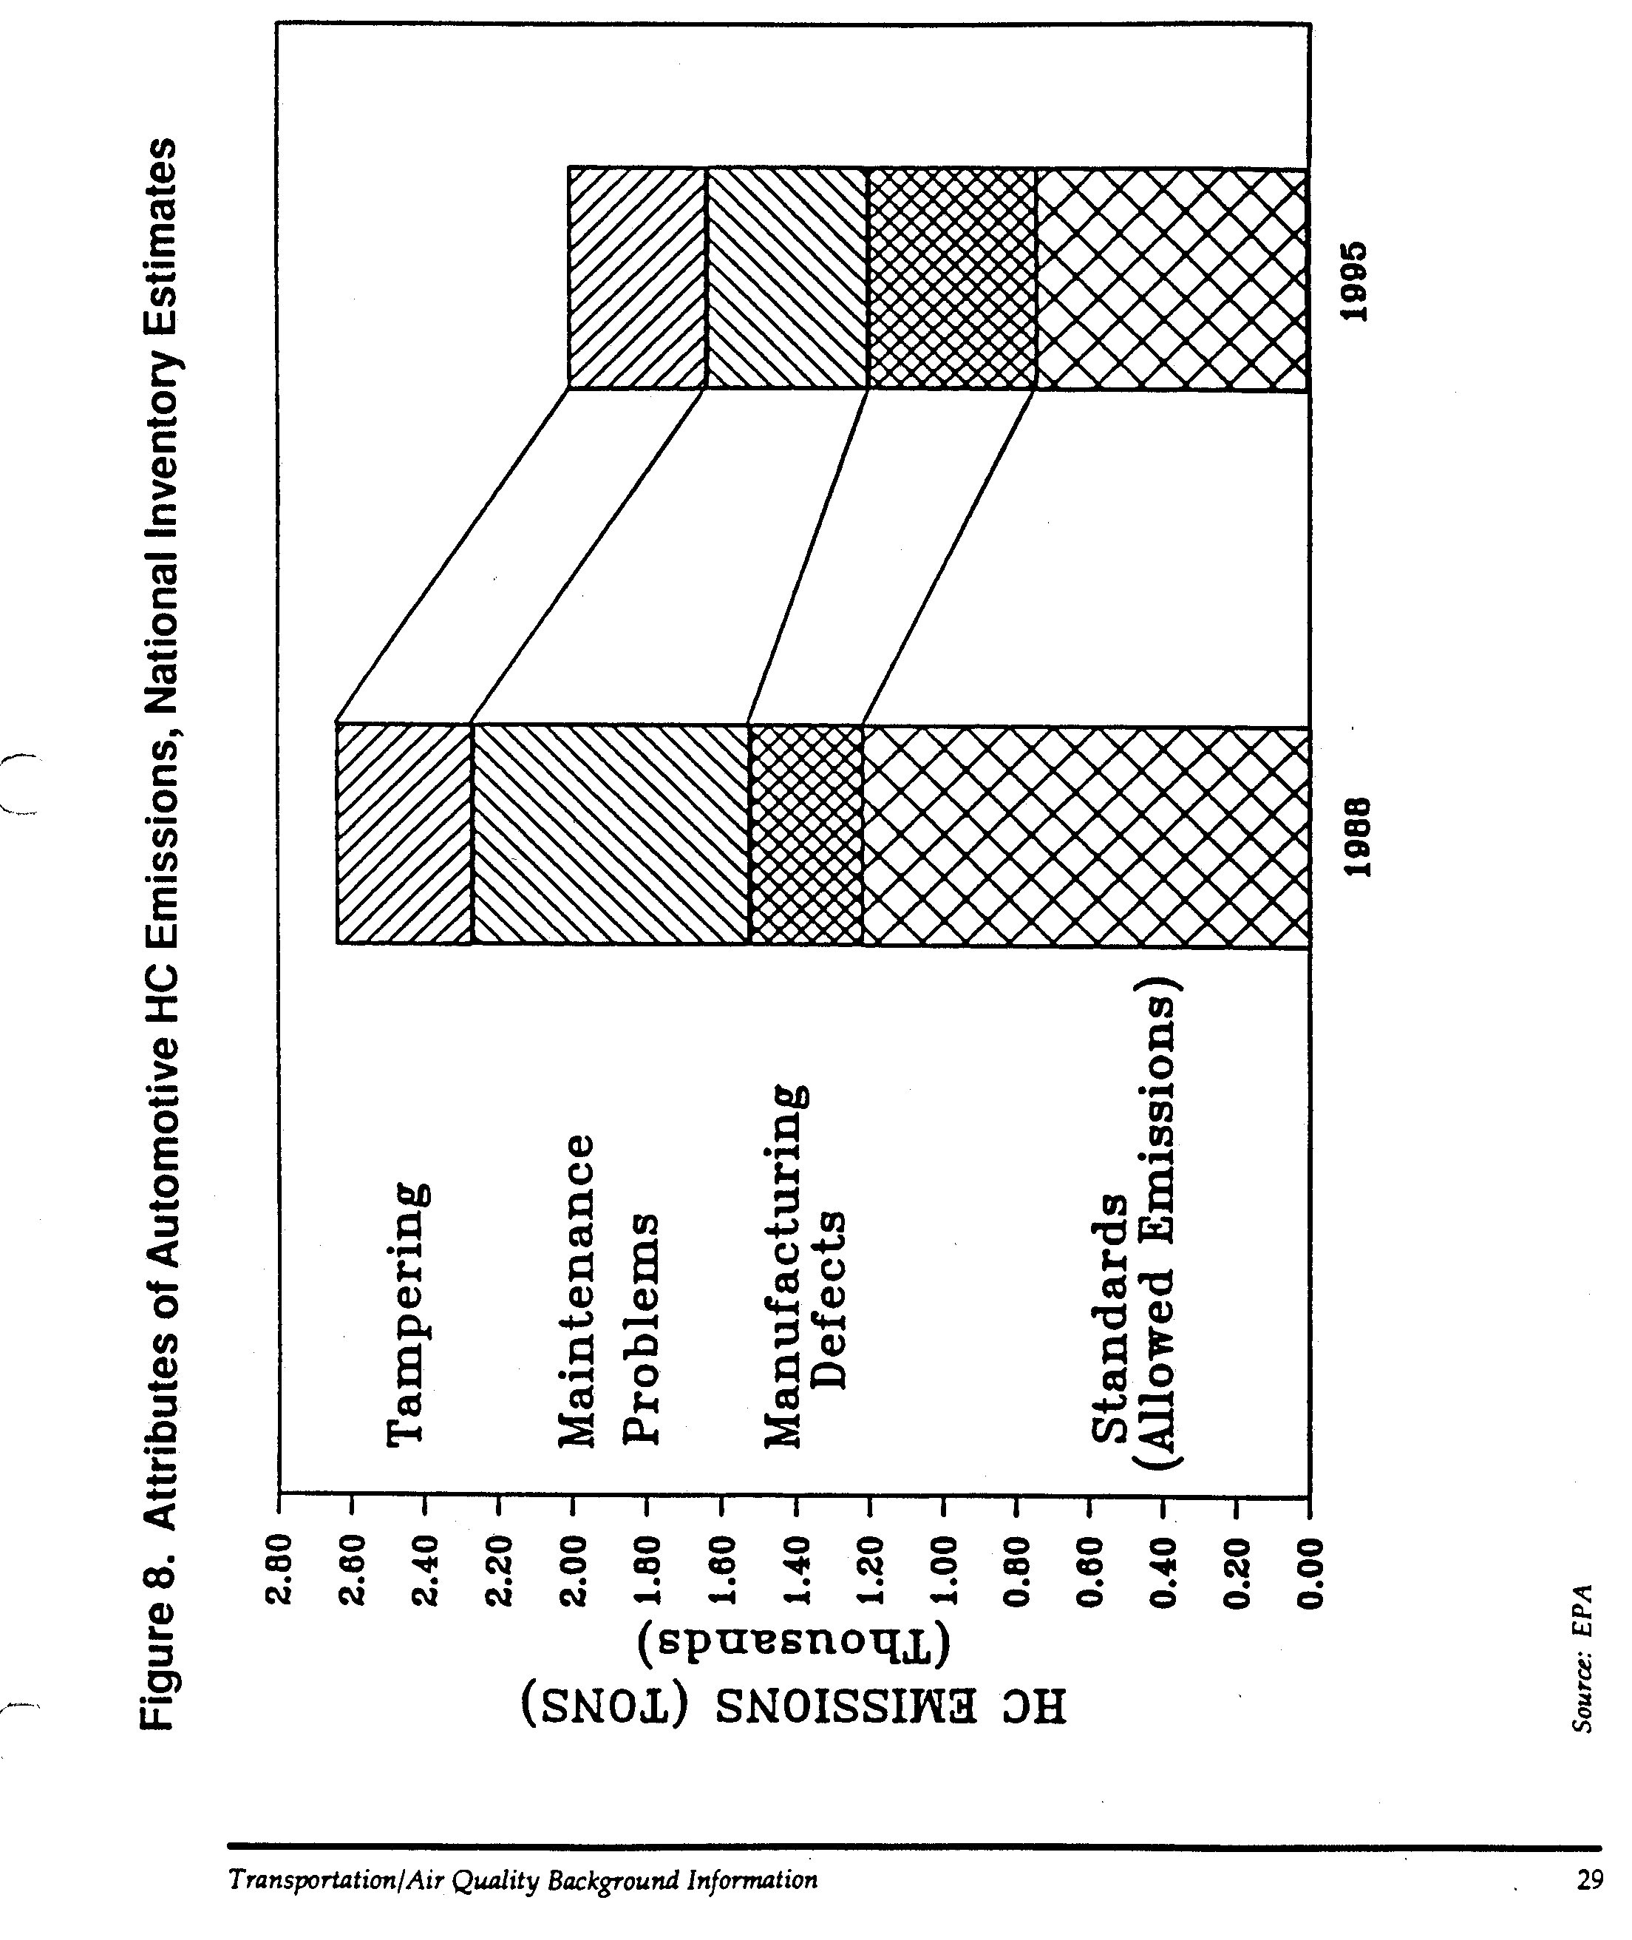
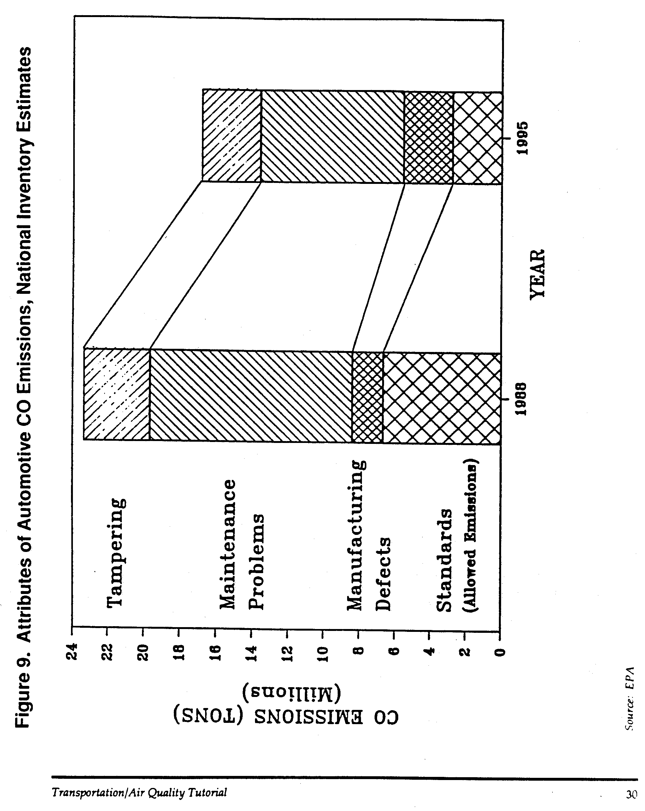
driving conditions. Diesel engine vehicles are also subject to emissions standards and employ technologies designed to reduce particulate and NOx emissions.

As a result of Clean Air Act requirements, the national vehicle fleet has gotten progressively cleaner through implementation of the Federal Motor Vehicle Emissions Standards. It should be noted, however, that overall increases in vehicle miles traveled are projected to eventually cancel out the gains achieved through the FMVES, in large part due to a greater number of total vehicles in operation.

Inspection and Maintenance (I/M)

Inspection and Maintenance programs are intended to identify vehicles with excessive emissions through a regularly scheduled inspection program. Once these vehicles are identified, they are either repaired or removed from the active fleet. I/M is a means of encouraging proper vehicle maintenance, assuring that emission control equipment is properly functioning, and deterring tampering and misfueling. Tampering with emission control equipment to disable it and reduce its effectiveness or using leaded gasoline in catalytic equipped automobiles can produce significant increases in emissions. I/M programs work hand-in-hand with programs for improved emission control technology by monitoring the effectiveness of control equipment on in-use vehicles and identifying problems relevant to the durability of equipment.

I/M is required under the Clean Air Act for areas which were unable to comply with standards for CO or Ozone. By 1987, approximately 30% of the national vehicle fleet participated in some type of I/M program. The actual operation of I/M programs varies between areas with regard to the standards which are enforced, the way in which the inspection is conducted, and the responsibility for conducting the inspection. Significant reductions of mobile source HC and CO emissions have been demonstrated to be feasible through I/M.

Transportation Control Measures (TCM)

Transportation Control Measures, or TCMs, are transportation strategies intended to both reduce vehicle miles of travel (VMT) and to make the VMT which is traveled more efficient. A basic precept of TCM programs is to reduce overall dependency on automobile use by diverting potential auto trips to other modes such as public transit, ridesharing, bicycling or walking or by reducing overall demand for travel by adding to the cost of tripmaking. For auto travel which does occur, TCM strategies are aimed at reducing cold-starts and delay and improving overall travel times, thereby reducing the frequency and amount of time the vehicle is in use. By reducing the total number of miles traveled by motor vehicles and by making those miles which are traveled more efficient, the total volume of mobile source emissions is reduced. TCM strategies illustrate the direct link between transportation and air quality planning.

The transportation control measures cited in Table 4 and described in these information documents include those identified in Section 108(f) of the new Clean Air Act. The chapters which follow discuss these measures in detail, describing implementation strategies, their effectiveness, and the costs associated with these TCM measures.

The term “transportation control Measure” or TCM encompasses elements of both “transportation system management” (TSM) and “transportation demand management” (TDM). Transportation system management strategies generally refer to the use of low capital intensive transportation improvements to increase the efficiency of transportation facilities and services. These can include carpool and vanpool programs, parking management, traffic flow improvements, preferential treatment of high occupancy vehicle, and park-and-ride lots. The TSM term also is applied to techniques used to reduce the demand for travel within an area. Transportation demand management generally refers to policies, programs, and actions that are directed towards increasing the use of high occupancy vehicles (transit, carpooling, and vanpooling) and the use of bicycling and walking. TDM also can include activities that encourage commuting outside the congested peak period, and that encourage telecommuting as an alternative to driving. In practice, there is considerable overlap among these three concepts and the terms TCM, TSM, and TDM often are used interchangeably.

Re-Fueling Controls

During the refueling of a vehicle, gasoline entering the fuel tank displaces fuel vapors which can escape into the air. Also gasoline which is unintentionally spilled during refueling evaporates into the air. Emissions from refueling generally are localized at service stations but contribute to an area’s total HC emissions.

Approximately 90% of all refueling emissions are the result of gasoline vapors being displaced by incoming fuel. The volume of these emissions is largely a function of temperature, tank size, and fuel volatility. Various approaches to controlling these emissions have been found to be effective. However there continues to be debate over how these controls should be implemented. Control technology can either be incorporated into the fuel system of the individual vehicle, adding to the cost of each vehicle, or incorporated into the design of the fuel pumping system, adding costs to the fuel distribution system.

Alternative Fuels

A great deal of research is currently being conducted in the areas of alternative and clean fuels. Researchers are hopeful of finding alternatives to gasoline and diesel fuels which do not produce the evaporative or combustion emissions of these fuels while not substantially adding to the cost of vehicle operation. Given such a scenario, it would be possible to operate environmentally “clean” vehicles without necessarily limiting their miles of travel.

Table 4. Available Transportation Control Measures

Trip Reduction Ordinances

Employer-Based Transportation Management Programs

Work Schedule Changes

Area-wide Rideshare Incentives

Improved Public Transit

High Occupancy Vehicle Lanes

Traffic Flow Improvements

Parking Management

Park-and-Ride/Fringe Parking

Bicycle and Pedestrian Programs

Special Events

Vehicle Use Limitations/Restrictions

Activity Centers

Accelerated Retirement of Vehicles

Extended Vehicle Idling

Extreme Low-Temperature Cold Starts

Unleaded fuel is now required to be sold in the United States, thereby allowing for the operation of catalytic converters and also reducing the amount of lead in the air. Fuel volatility, as measured by Reid vapor pressure (RVP), affects evaporative emissions and, to a lesser extent, exhaust emissions. In recent years, gasoline manufacturers have increased RVP levels, thus contributing to higher levels of vehicle emissions. The fuel volatility provisions of the new Clean Air Act require the promulgation of regulations that gasoline marketed during the high ozone season must have a RVP of 9.0 psi or less, beginning no later than 1992.

In addition to changing the composition of gasoline, alternative fuels such as alcohol, compressed natural gas (CNG), and electricity could become practical alternatives to petroleum-based fuels.

There is currently a great deal of interest in methanol fuels – M85 (a blend of 85% methanol and 15% gasoline) and M100 (neat methanol). These fuels have a low ozone-forming potential compared to gasoline. However, there is significant difference of opinion surrounding methanol due, in part, to the potential impact on the petroleum and automobile manufacturing industries resulting from conversion to methanol and also due to its potential costs.

Tests have indicated that conversion from gasoline to methanol fueled light duty vehicles would result in a 50% reduction in emissions of reactive organic compounds, leading to a decrease in ozone production from vehicle emissions, and a 40% reduction in CO. There is no effective change in emissions levels of nitrogen oxides. For diesel-fueled vehicles, conversion to methanol virtually eliminates particulate matter and reduces NOx emissions by 50%. On the other hand, formaldehyde is found in significant quantities in methanol exhaust emissions because it is a primary oxidation product of methanol. Formaldehyde is classified as a probably human carcinogen. Other health and safety concerns regarding the widespread availability of methanol include its acute toxicity when ingested or absorbed through the skin; its colorless, odorless, and tasteless nature (which could lead to more incidences of accidental ingestion); and its tendency to burn with an invisible flame. Proponents of methanol claim that its potential hazards are different from, but not necessarily worse than, those of gasoline.

Other fuels receiving attention include hydrogen, liquefied petroleum gases (LPG), and ethanol made from farm products. Although electric vehicles have been produced and are in limited general use in some European countries, driving distances between battery charges is limited and cost-efficient electrical storage systems are still being perfected. Although CNG presents a number of issues relevant to its delivery system and refueling process, there are already 30,000 CNG vehicles operating in the U.S. Reformulated gasoline, as a liquid fuel comparable to gasoline, would have limited impact on fuel delivery systems and vehicle design. However, it could require a sizable investment in modifications to the petroleum refinement industry.

Transportation/Air Quality Planning and Modeling

The transportation/air quality planning process involves a variety of interrelated activities for which the ultimate goal is to reduce emissions from transportation sources and improve overall air quality. To summarize these activities, the process involves:

  - Quantification of the problem;

  - Design of control strategies; and

  - Demonstration of future NAAQS attainment with an ongoing program of monitoring and maintenance.

The process is encompassed within the State Implementation Plan, or SIP, which is the comprehensive document that quantifies current emissions and air quality conditions, and presents federally enforceable commitments to implement measures that are sufficient to achieve the national ambient air quality standards by a designated date. Reinforcing the SIP process is the requirement for annual reporting of “reasonable further progress” (RFP) toward achieving attainment of standards; in effect verifying a non-attainment area’s continuing efforts to improve air quality.

Quantification of the Problem

Monitoring
In order to collect air quality data to determine whether an area has attained air quality standards for a criteria pollutant or is in violation of NAAQS, air quality is monitored by mechanical devices which collect and test samples of the air. Specific procedures have been developed for scientifically sampling ozone, carbon monoxide, NOx, and other criteria pollutants. Data are normally collected throughout the year in order to represent the full range of temperature and weather conditions, as well as spatial and time-of-day variations. For carbon monoxide, monitors are located so as to isolate background levels from pollution caused directly by specific traffic conditions. These monitoring data are used to calibrate the air quality models that are used to predict changes in future air quality.

Inventories
While the monitoring of air quality can quantify air quality conditions within a given area, air quality inventories quantify the sources of emissions of criteria pollutants within an area. Emissions inventories are developed through the SIP process for all significant mobile, stationary, and area sources of pollutants. Inventories are developed for both a designated base year and a projected future year, providing a baseline condition against which the effectiveness of alternative control programs can be measured. Mobile source inventories include all transportation-related sources of emissions – highway vehicles, off-highway vehicles, aircraft, railroads, and marine vessels. Emissions from highway vehicles are further disaggregated by vehicle type and are based on estimates of vehicle miles of travel by both vehicle type and roadway classification. The accuracy of mobile source inventories is closely correlated with the level of detail at which data is analyzed. Geographic and temporal disaggregation, for example, at the traffic analysis zone and peak travel period levels of detail are desirable.

A variety of techniques are used to develop highway emissions inventories, including traffic counts (such as those developed for the Highway Performance Monitoring System (HPMS) and computer-based transportation network analysis. Use of the Federal Highway Administration’s UTPS (Urban Transportation Planning System) model, or one of the many microcomputer variations, is common. However, because these systems were not generally developed for air quality analyses, care must be taken in their application, often involving collection of supplementary data and adjustments to the model. For example, local roads which may carry small volumes of traffic may not be represented in traffic network models but must be accounted for in a comprehensive air quality inventory. Because emission production is closely correlated with vehicle speeds, an accurate assessment of vehicle travel times and speeds is critical.

Emission Factor Models
A key component in the quantification process is the conversion of vehicles miles of travel, vehicle speeds, and vehicle types into estimates of emissions. This is done using an emissions factor model such as EPA’s MOBILE4.1. MOBILE4.1 is a complex computer program that has evolved over time that accounts for the many variables which affect production of emissions by motor vehicles. Factors taken into consideration include fuel volatility, temperature, range of daily ambient temperature, altitude, humidity, vehicle type, age of the vehicle, accumulated miles of vehicle travel, vehicle speed, characteristics of an area’s inspection/maintenance program, the effects of tampering and anti-tampering programs, and analysis year. Based on inputs into the program accounting for these and other variations in vehicle and travel characteristics affecting emission production, MOBILE4.1 can be used to calculate a range of emission factors in grams of pollutant per mile, which is then multiplied by the appropriate vehicle miles of travel to determine total emissions.

Design of Control Strategies

The development of an emissions control strategy for inclusion in the State Implementation Plan must differentiate between the three primary categories of emissions: stationary, area, and mobile. It must also account for existing versus future sources. If an area can attain NAAQS from limits on new stationary and mobile sources, then no further strategies are warranted. If however, limitations on new sources are insufficient, which is generally the case in urbanized areas, then through the inventory process, agencies must identify all existing sources of emissions and the volumes of pollutants emitted. Projections must also be made of how these sources might increase over time as a result of growth.

Local officials must then determine the costs and technological feasibility of controlling these sources of emissions. If adequate reductions can be accomplished through stationary and area source measures, mobile source controls may not be necessary. Generally, the most effective control programs involve the replacement of older, less efficient emission sources with newer, cleaner processes or by retrofitting existing sources. However, for carbon monoxide and ozone precursors, in particular, stationary source controls alone plus new vehicle controls are expected to be insufficient in many cases.

In those cases when an urbanized area cannot show attainment of NAAQS for ozone or carbon monoxide, transportation control measures may be needed to supplement reductions achieved through other source controls. In order to assure that such measures have a high feasibility for implementation, rather than placing the sole authority for the planning of transportation control measures with state environmental agencies, the Clean Air Act Amendments of 1977 required that local officials be made part of the planning process. The mechanism for local official involvement is the metropolitan planning organization (MPO), the organization of local elected officials responsible for the “continuing, cooperative, and comprehensive” (3C) planning process for the area, as established through the Federal Aid Highway Act.

With the participation of a MPO, communication involving transportation agencies environmental agencies and groups, business organizations, citizen groups, and other potentially affected interests can be facilitated, making implementation of TCMs more likely. Through a process of consultation and planning, the MPO prepares plans and capital programs which are incorporated into the Transportation Improvement Program (TIP) for an area, which must be approved by the MPO’s governing board of elected officials. When the plans finally receive local approval, they are submitted to the State air agency for review and incorporation into the SIP. State and local transportation agencies are then responsible for implementation of TCMs included in the SIP.

Demonstration of Attainment

Once a strategy and implementation schedule is determined by a non-attainment area for meeting NAAQS, the SIP must demonstrate that the strategy will be successful in accomplishing its goals. Many air quality-related transportation analyses operate with emissions as the basic unit of analysis. This approach assumes that air quality will be improved on relatively the same proportion as the magnitude of reduced emissions. This is referred to as a “rollback” approach. However, this approach generally cannot account for temporal and meteorological factors which can have significant influence on pollutant levels. “Atmospheric dispersion models,” on the other hand, can be used to convert geographic and temporal distributions of emissions into estimates of atmospheric concentrations of air pollutants. Dispersion analyses often utilize complex grid-based mathematical computer simulations which account for meteorological conditions in combination with estimates of mobile, stationary, and area source emissions to estimate pollutant concentrations by time of day.

Regional or mesoscale dispersion models are commonly used in developing an area wide ozone plan. Microscale dispersion models, such as CALINE, are used for project-level CO analyses and are applied at a more localized scale. However, dispersion modeling is complex, involving a significant commitment of time and budget. As a result, simplified approaches to regional modeling, such as EKMA (Empirical Kinetic Modeling Approach), often have been used for transportation analyses. EKMA includes a detailed approach to atmospheric chemistry but also simplifies many variables within a modeled area, thereby limiting its accuracy. As a result, more and more areas are tending toward use of grid-based models such as the Urban Airshed Model (UAM). This model simulates the physical and chemical processes in the atmosphere that affect pollutant concentrations. It is capable of calculating both summertime ozone concentrations and wintertime carbon monoxide concentrations. Because UAM accounts for spatial and temporal variations as well as differences in reactivity of emissions, it is well suited for evaluating effects of emissions control strategies on urban air quality.

As required through the SIP process, the demonstration of “reasonable further progress” involves an examination of current air quality trends to determine year-to-year changes in air quality. Ideally, this is done through combinations of monitoring, air quality modeling, and development of annual inventories. However these techniques are expensive and time-consuming, making annual analysis at this level of detail impractical. Important criteria for emissions trends analyses are consistency and timeliness. Consistent data and methodologies should be used to ensure year-to-year comparability; and the analysis should be able to be accomplished relatively quickly in order to provide meaningful information to local officials. Therefore, trends analyses typically take the form of a simplified inventory using easily obtainable data as basic input variables. Fuel sales data is often analyzed, based on either direct sales reports or tax receipts, and converted into estimates of vehicle miles of travel and emissions. Traffic counts also can be utilized, with conversion into measures of VMT and emissions. These procedures can be disaggregated by month, year, or geographic subdivision as appropriate.

Bibliography

Books and Papers

- Cambridge Systematics, Inc. “Current Status of Transportation Air Quality Regulations in the United States,” prepared for Ministry of Communications, Department of Transport Economy, Helsinki, Finland, March 1990.

- DeLucci, Mark et al, “A comparative Analysis of Future Transportation Fuels,” Institute of Transportation Studies, University of California, Berkeley, CA, October 1987.

- Gushee, David E., and Sandra Sieg-Ross, “The Role of Transportation Controls in Urban Air Quality,” Congressional Research Service, January 1988.

- Horowitz, Joel, Air Quality Analysis for Urban Transportation Planning, MIT Press, Cambridge, MA, 1982.

- Sperling, Daniel, “California’s Quest for Clean Fuels and Vehicles,” presented at Energy and the Environment in the 21st Century Conference, MIT, Cambridge, MA, 1990.

- State of California Air Resources Board, “The Air Pollution-Transportation Linkage,” Office of Strategic Planning, Sacramento, CA, 1989.

- U.S. Environmental Protection Agency, Urban Airshed Model User’s Guide, 1990.

- U.S. Environmental Protection Agency, Procedures for Emission Inventory Preparation, Volume IV, Mobile Sources, July 1989.

- U.S. Environmental Protection Agency, Office of Air and Radiation, User’s Guide to MOBILE4, Office of Mobile Sources, Ann Arbor, MI, February 1989.

- U.S. General Accounting Office, Traffic Congestion: Trends, Measures, and Effects, Report to the Subcommittee on Transportation and Related Agencies, Committee on Appropriations, U.S. Senate, Washington, D.C., November 1989.

- Walsh, Michael P. “Critical Analysis of Federal Motor Vehicle Control Program,” Prepared for Northeast States for Coordinated Air Use Management, July 1988.

- Walsh, Michael P. “Pollution on Wheels II: The Car of the Future,” American Lung Association, Washington, D.C., January 1990.

Articles

- “Air: An Atmosphere of Uncertainty,” by Noel Grove, National Geographic Magazine, April 1987.

- “Effect of Transportation on Ozone in Cities,” by Philip M. Roth, TR News, Transportation Research Board, May-June 1990.

- “Clean Air Act Amendments and Highway Programs,” by B. Beckham, W. Reilly, and W. Becker, TR News, Transportation Research Board, May-June 1990.

- “Determining Alternative Fuels Strategies,” by J.L. Levine, TR News, Transportation Research Board, May-June 1990.

